Deploy Your .NET Core 9 Web API to Azure For FREE | CI/CD with Azure DevOps
https://youtu.be/8tYvsO4emAc
Web API creation 0.1
Move your project from GitHub to Azure DevOps 11.26
check this video below
Git & Azure DevOps for absolute beginners!
https://youtu.be/Lky9qQsohiA
Set up CI/CD Pipelines for automated deployment 13.38
at 36.03 he recommend below video
Deploy Angular App to Azure Web App with Azure DevOps | CI/CD Pipeline | Multi-Stage Deployment
https://youtu.be/fqI0ToX1nDQ
Full Stack Angular & .NET Core Projects | Real-World Web App
https://www.youtube.com/playlist?list=PLVlM_EVY85XsKwORCZ5_zH_eXp8me-ilM
Deploy .NET 10 API + React Apps to Azure with GitHub Actions CI/CD | In Hindi
https://youtu.be/w9foALxHnQo
I have used Free Azure subscription for below work
- Git & Azure DevOps for absolute beginners!
https://youtu.be/Lky9qQsohiA
Waghven Technologies
WaghvenTechnology
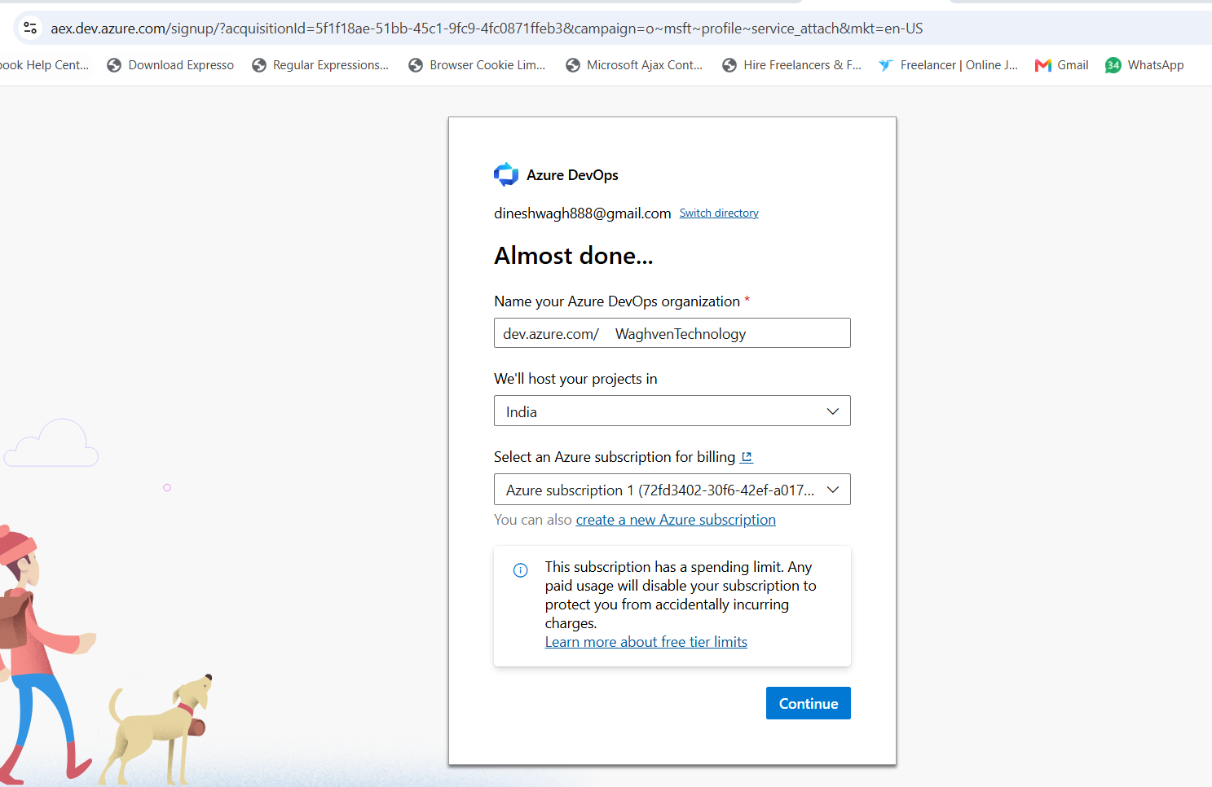
https://dev.azure.com/WaghvenTechnology/?acquisitionId=5f1f18ae-51bb-45c1-9fc9-4fc0871ffeb3&acquisition=true
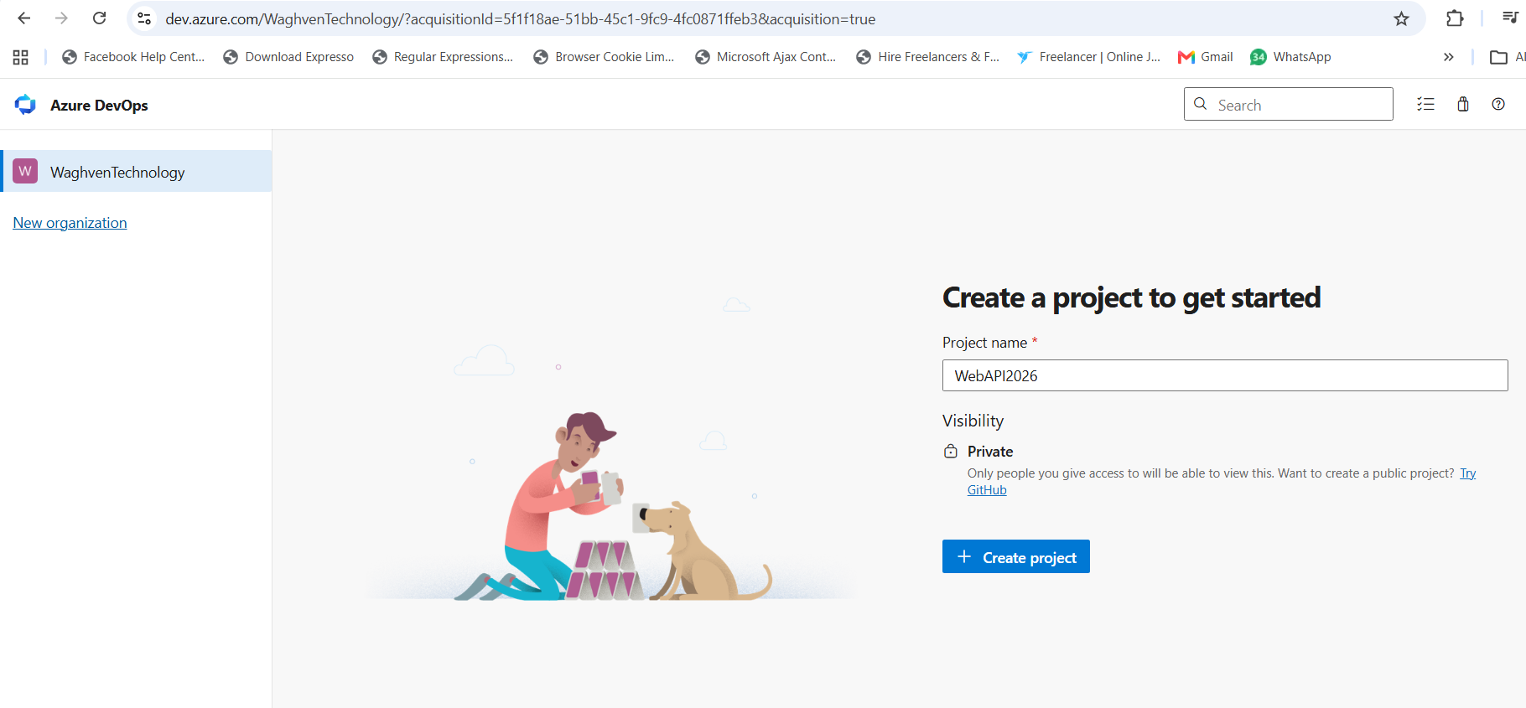
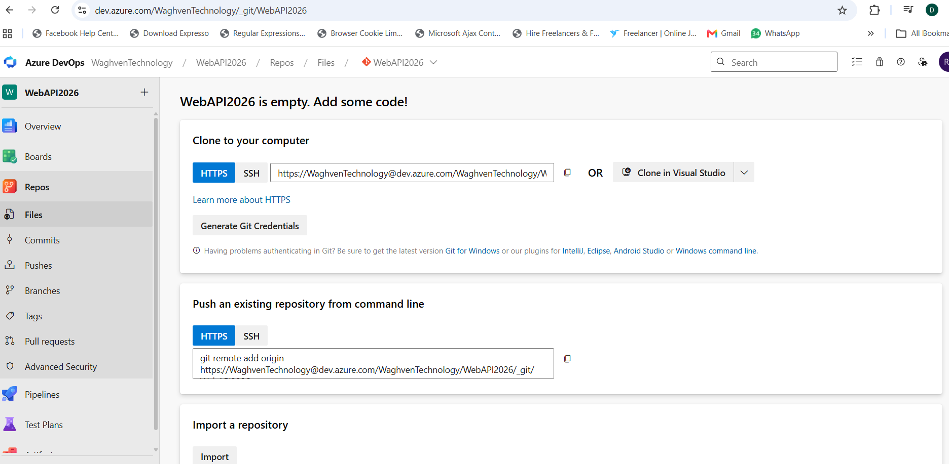
Add repo into Azure devOps
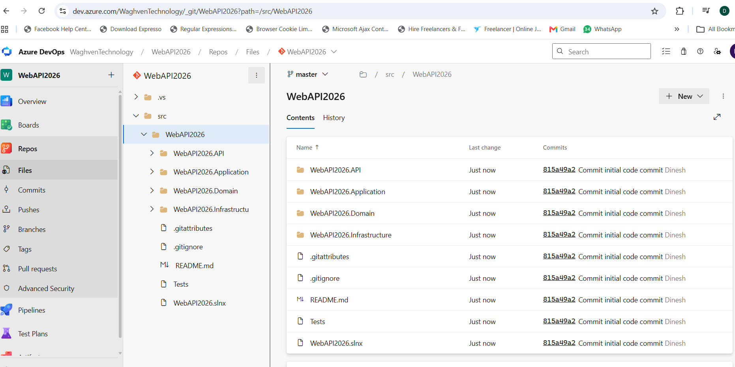

- How to configure branch policies in Azure DevOps | Pull request creation and approval
https://youtu.be/2QL-j9bzhdM

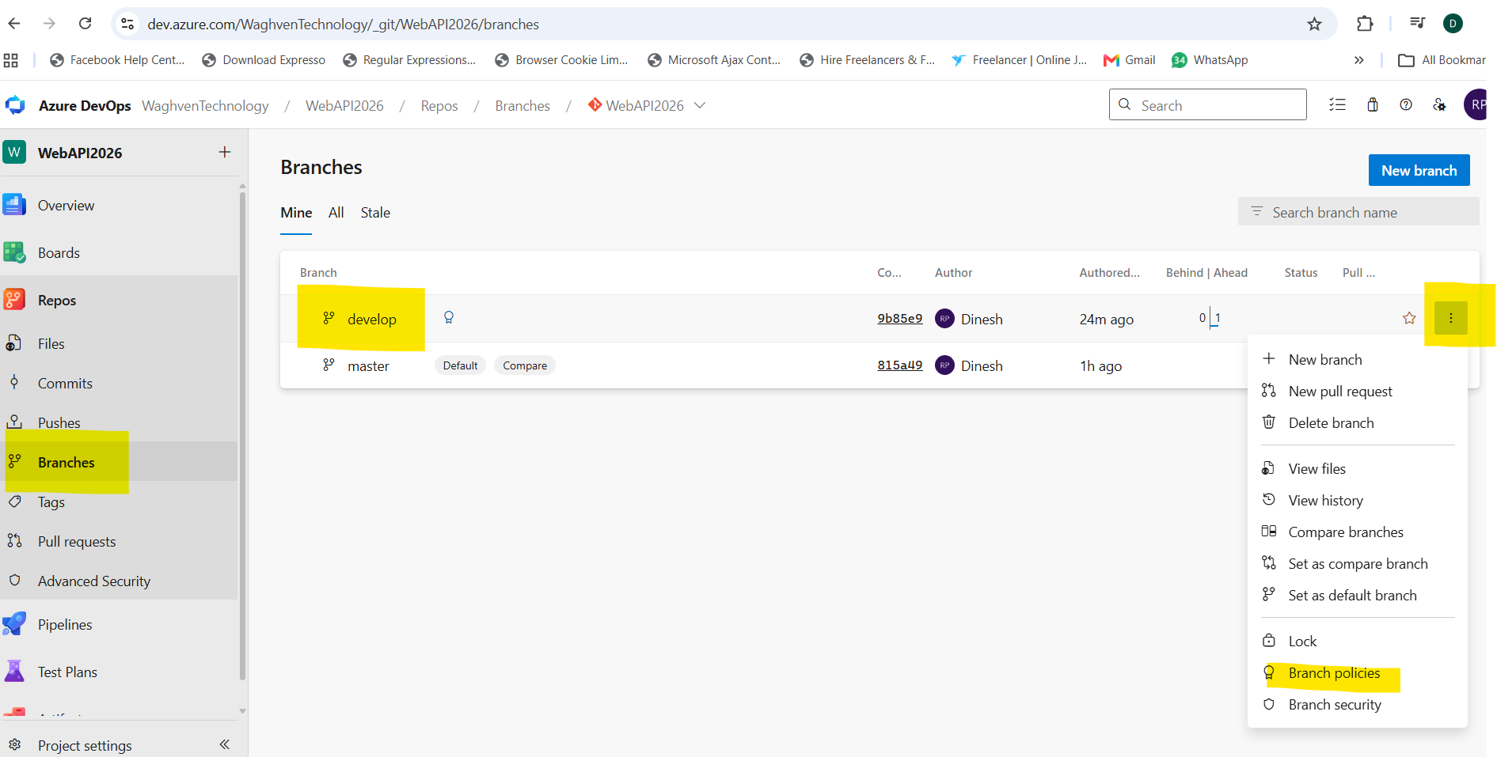

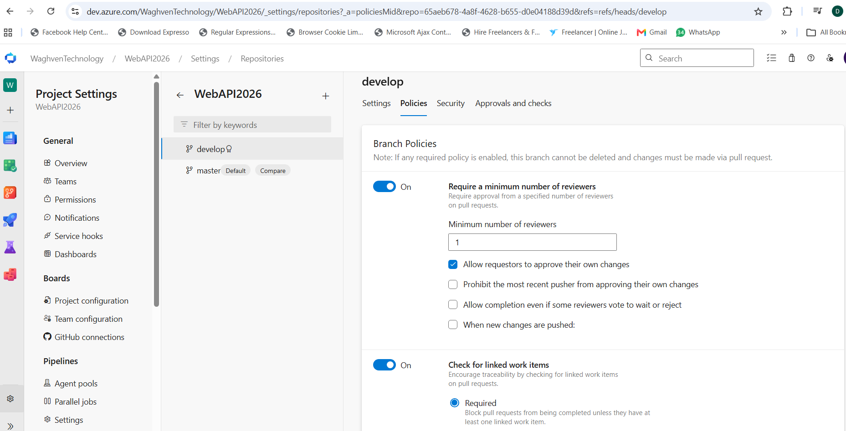

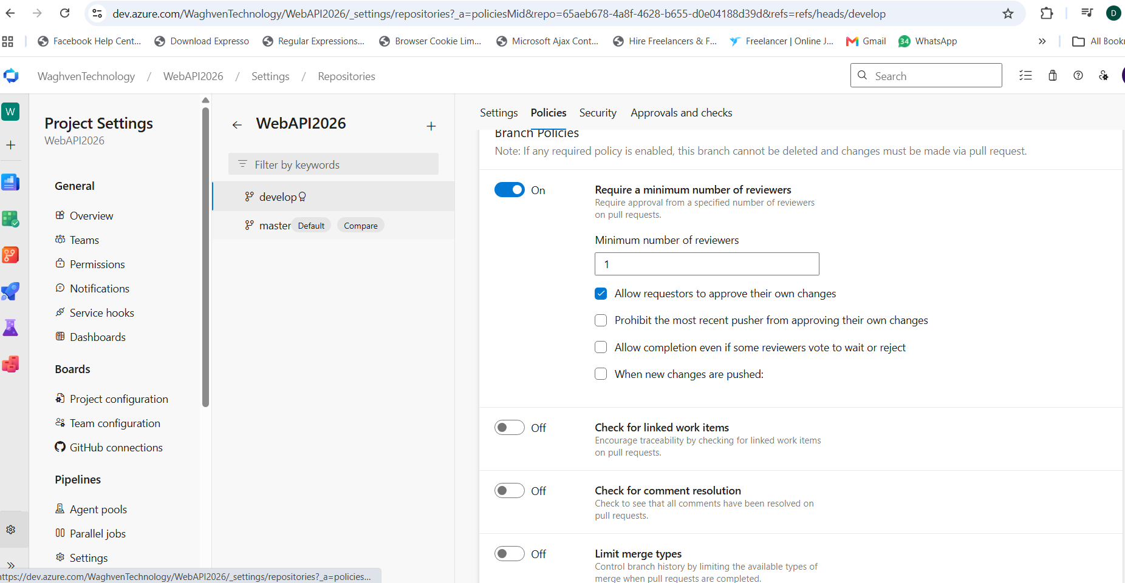
Due to policy getting below error
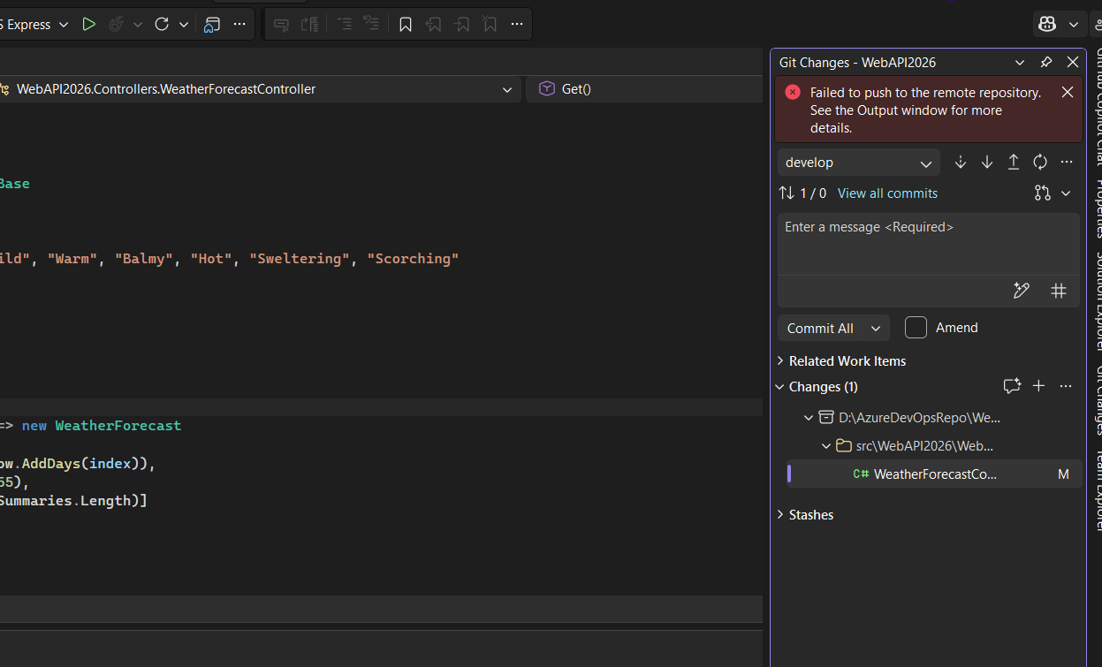
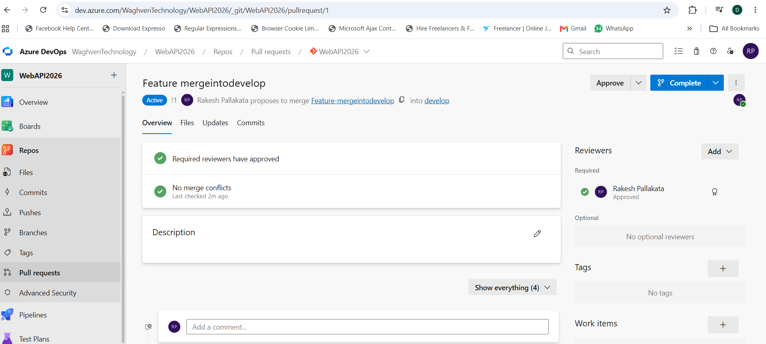
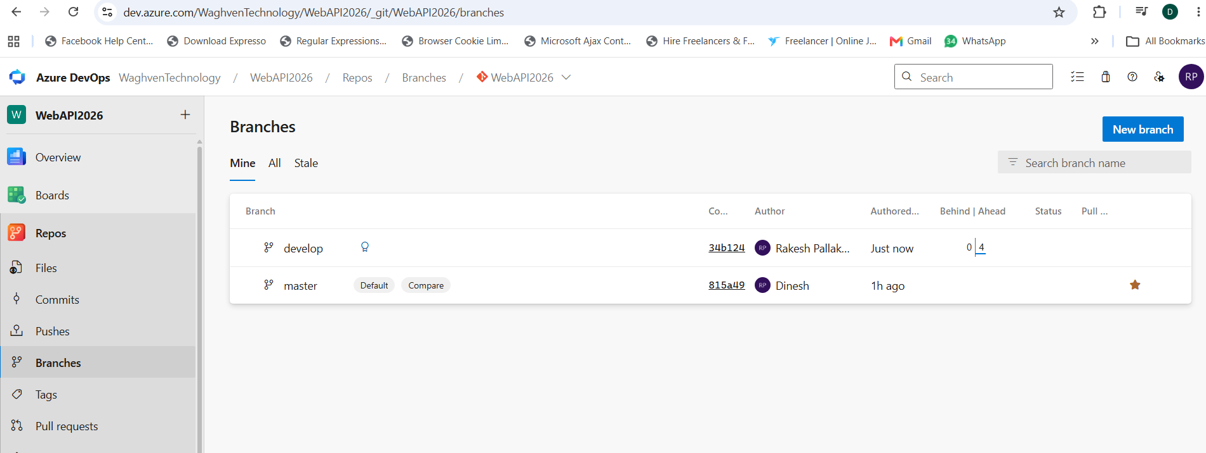
- Deploy Your .NET Core 9 Web API to Azure For FREE | CI/CD with Azure DevOps
https://youtu.be/8tYvsO4emAc
testWebAPI2026
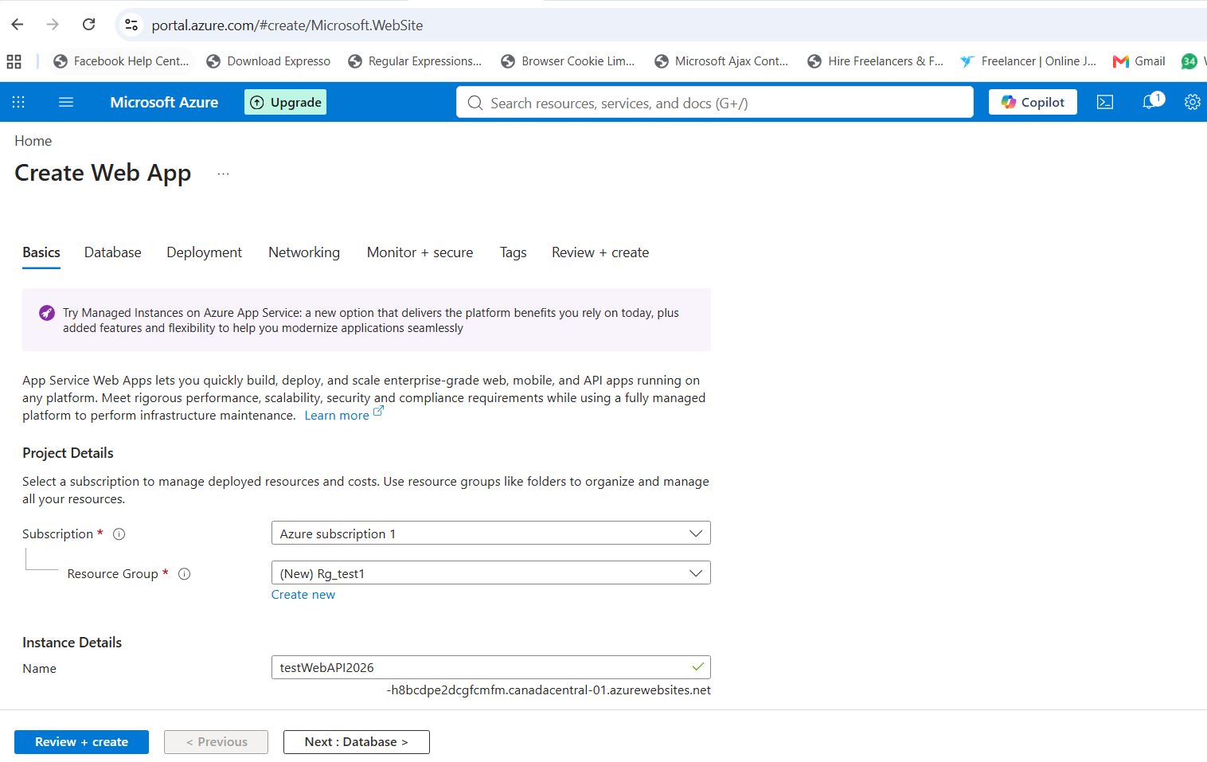
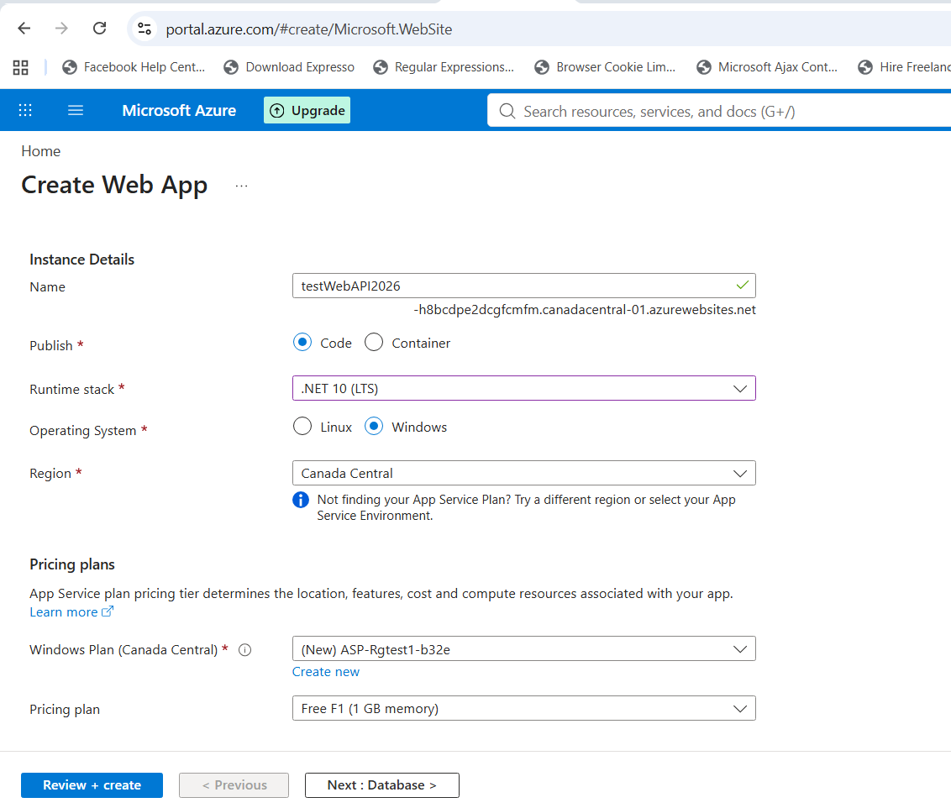
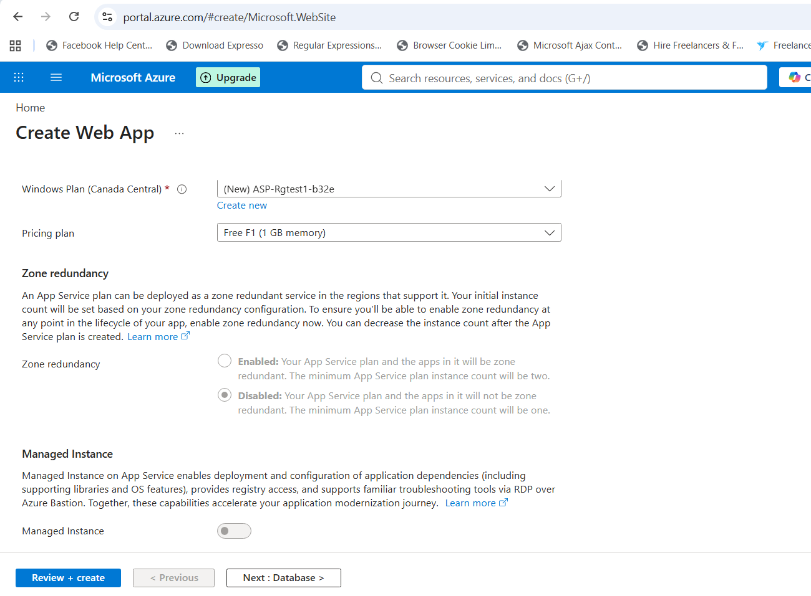
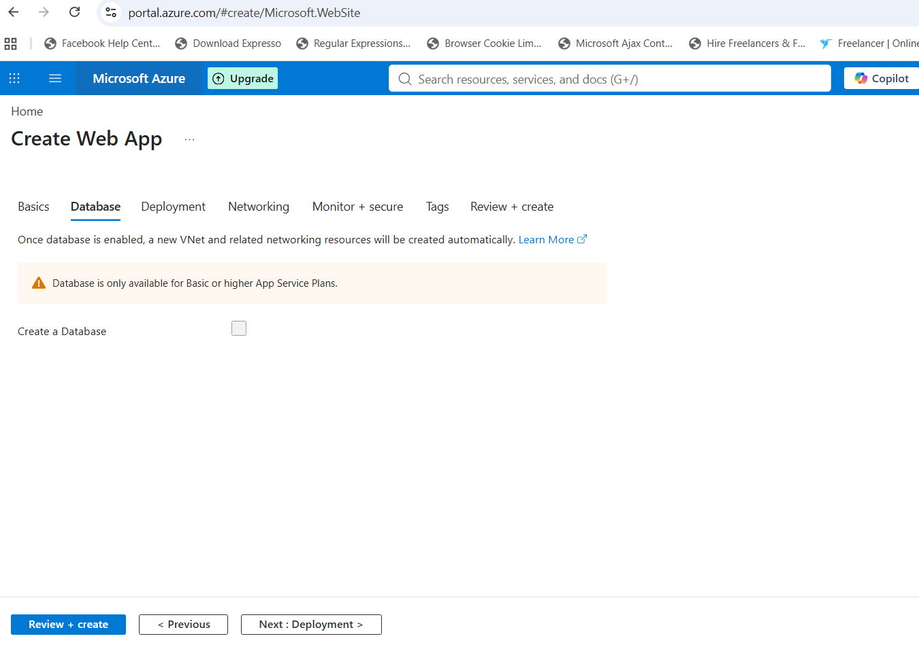
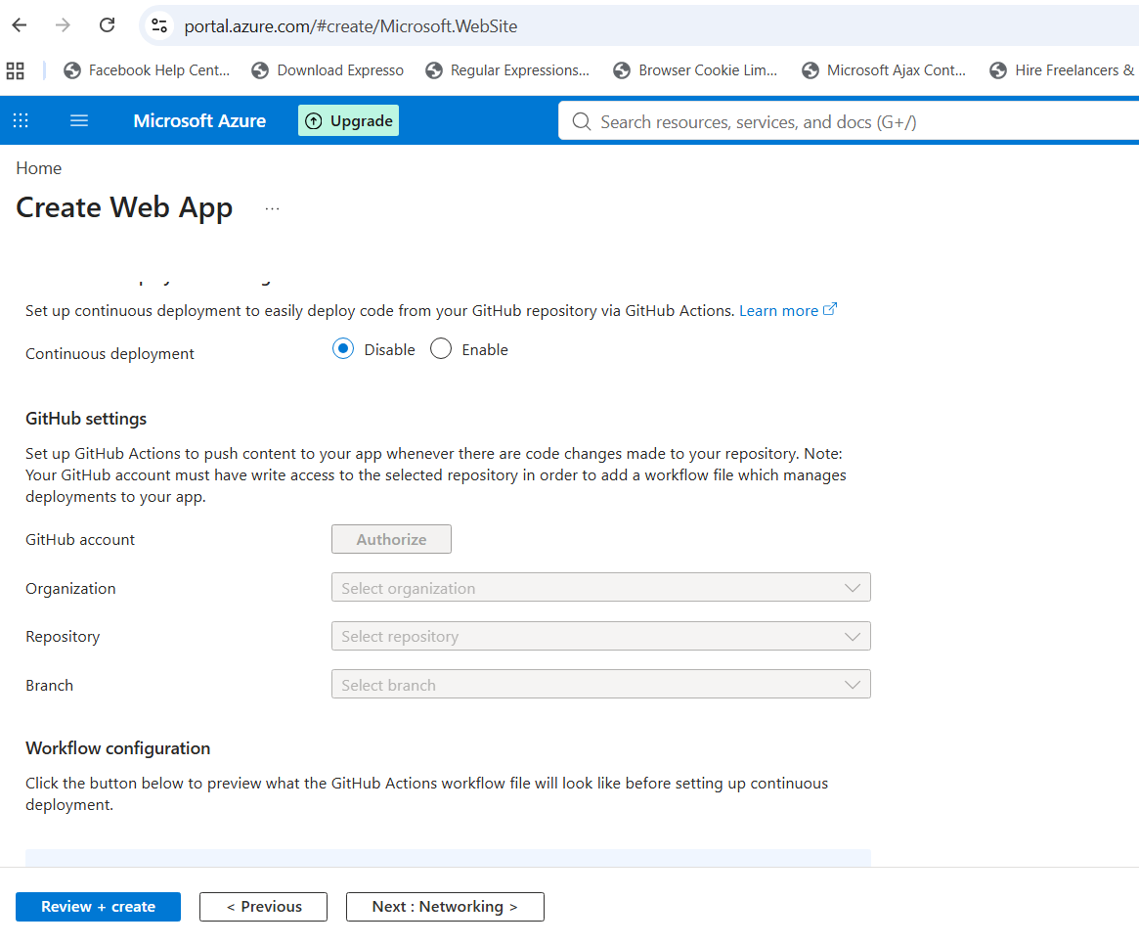
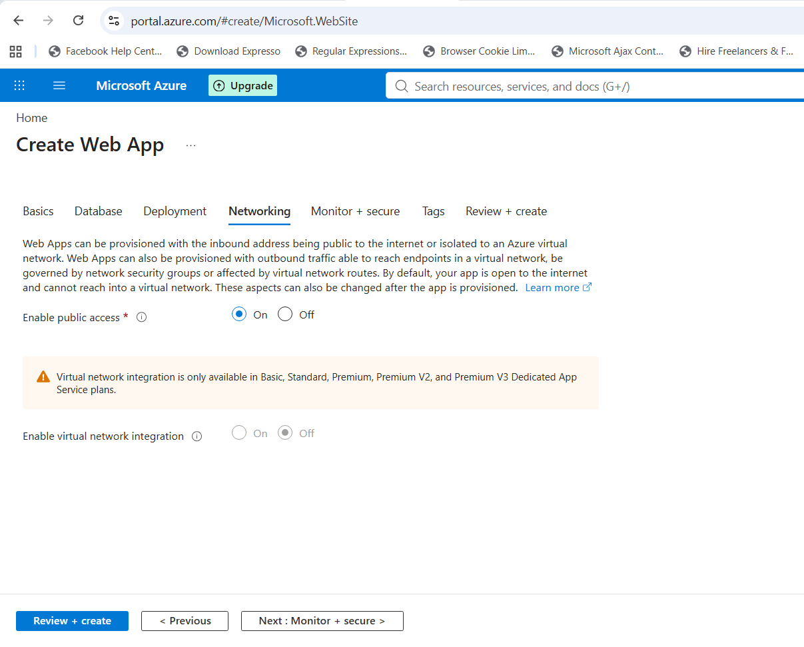
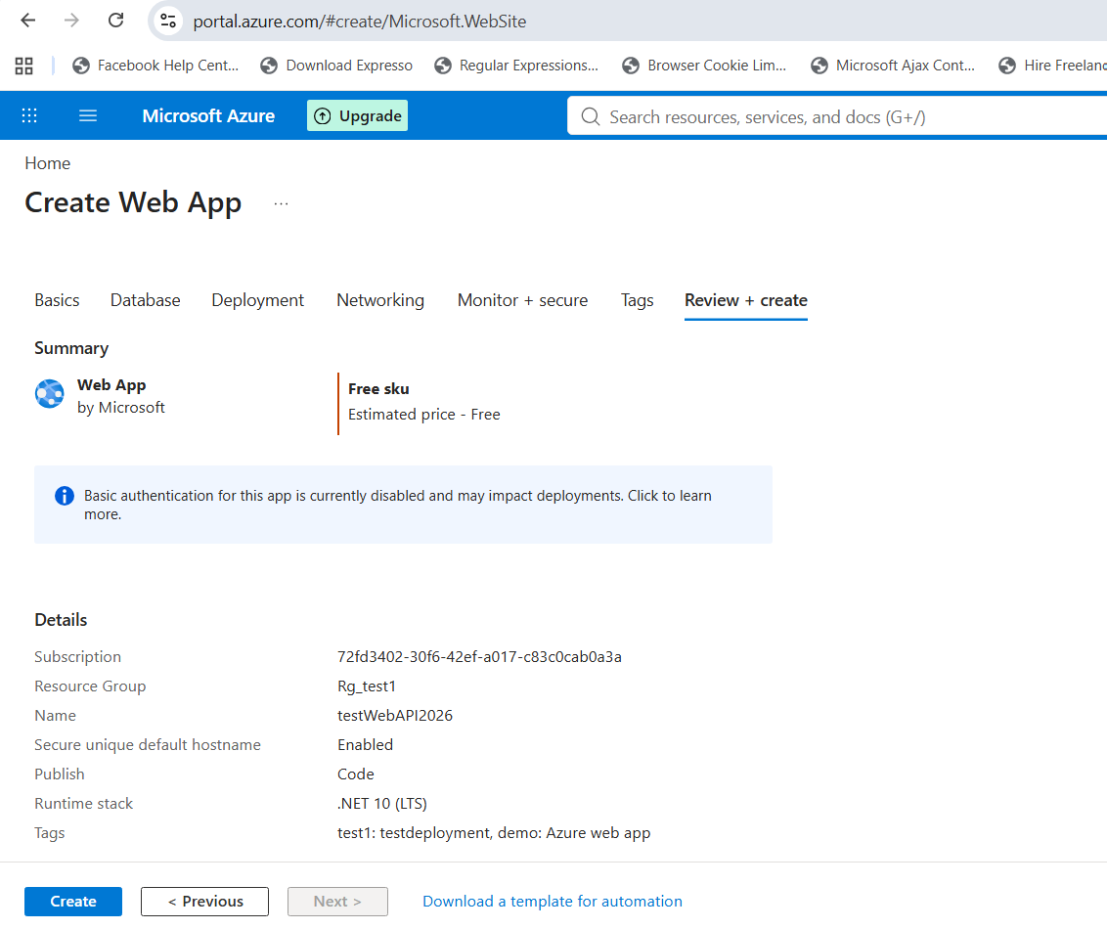
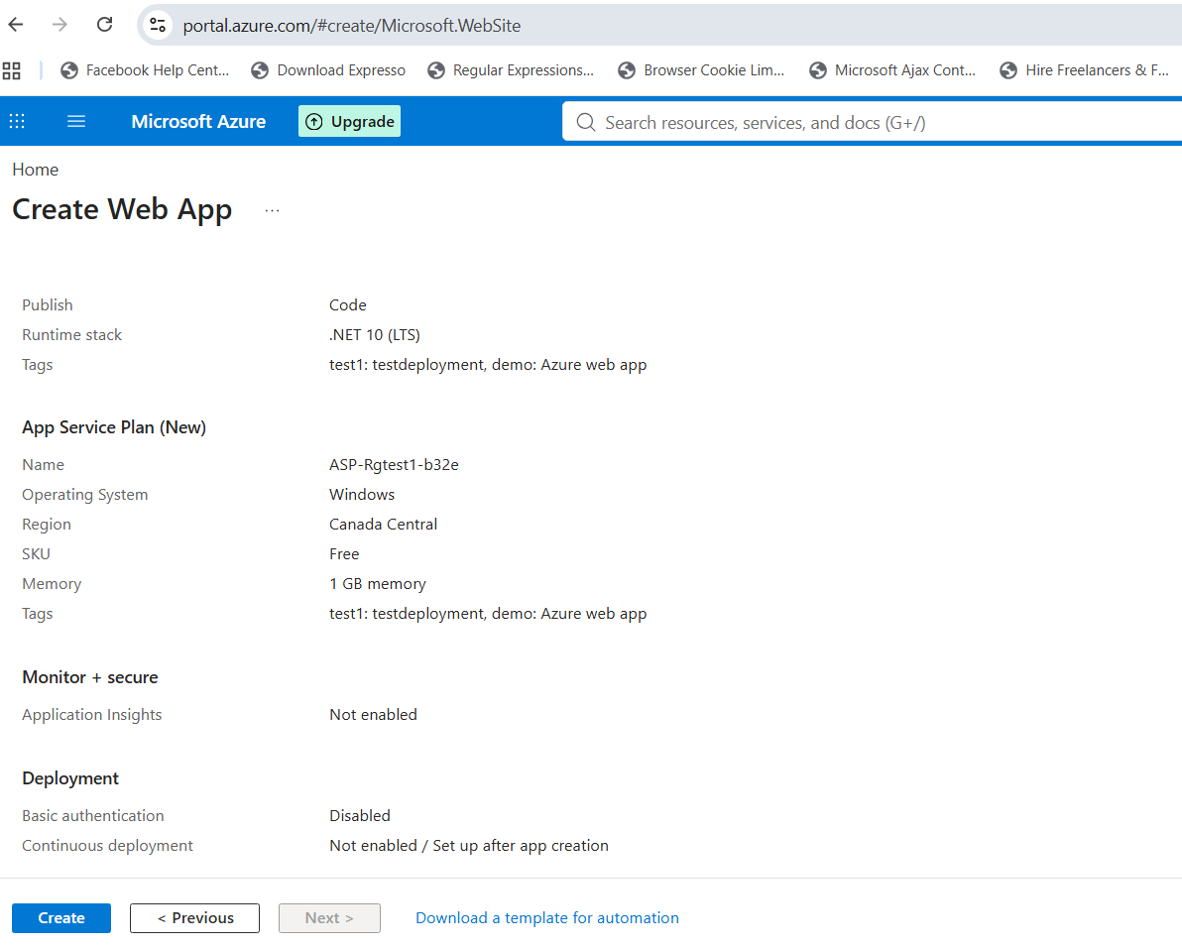
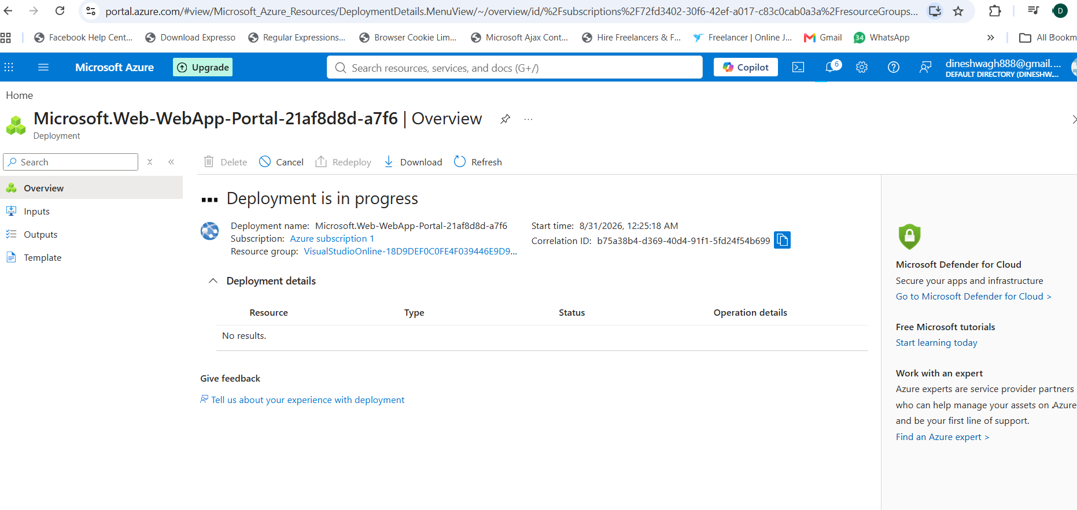
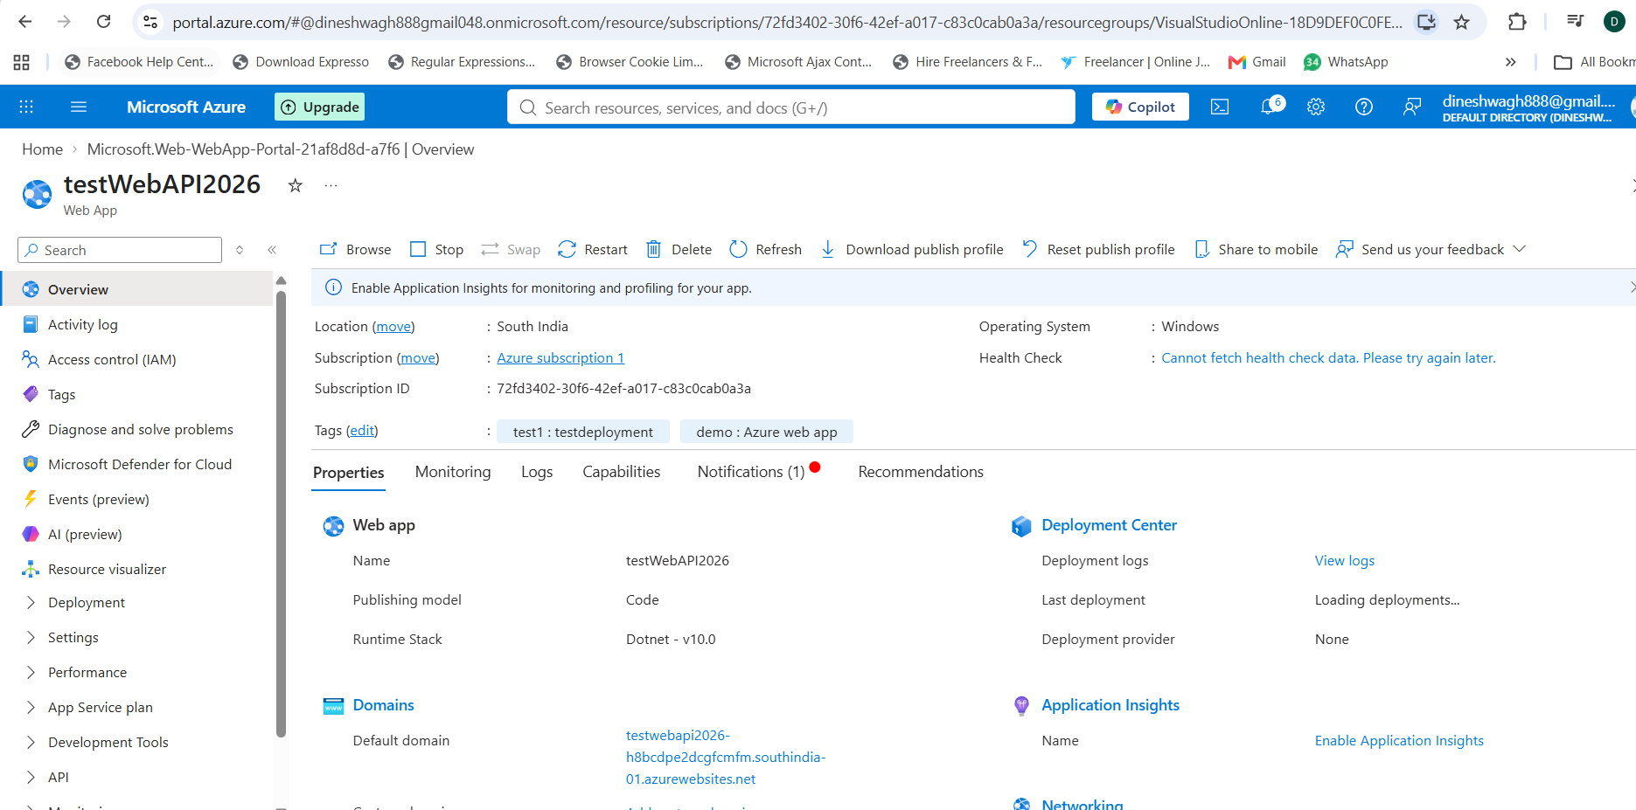

Create pipeline
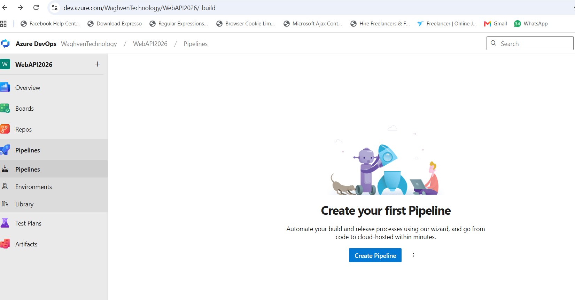
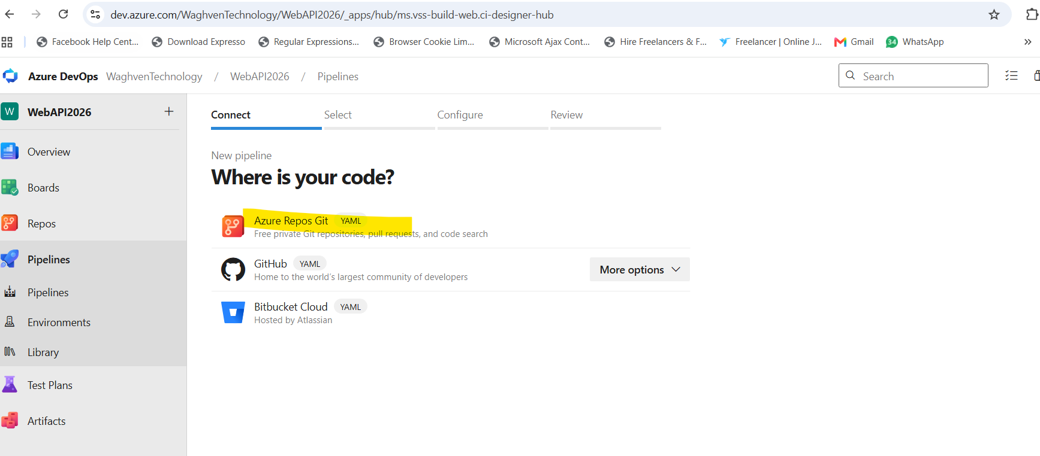
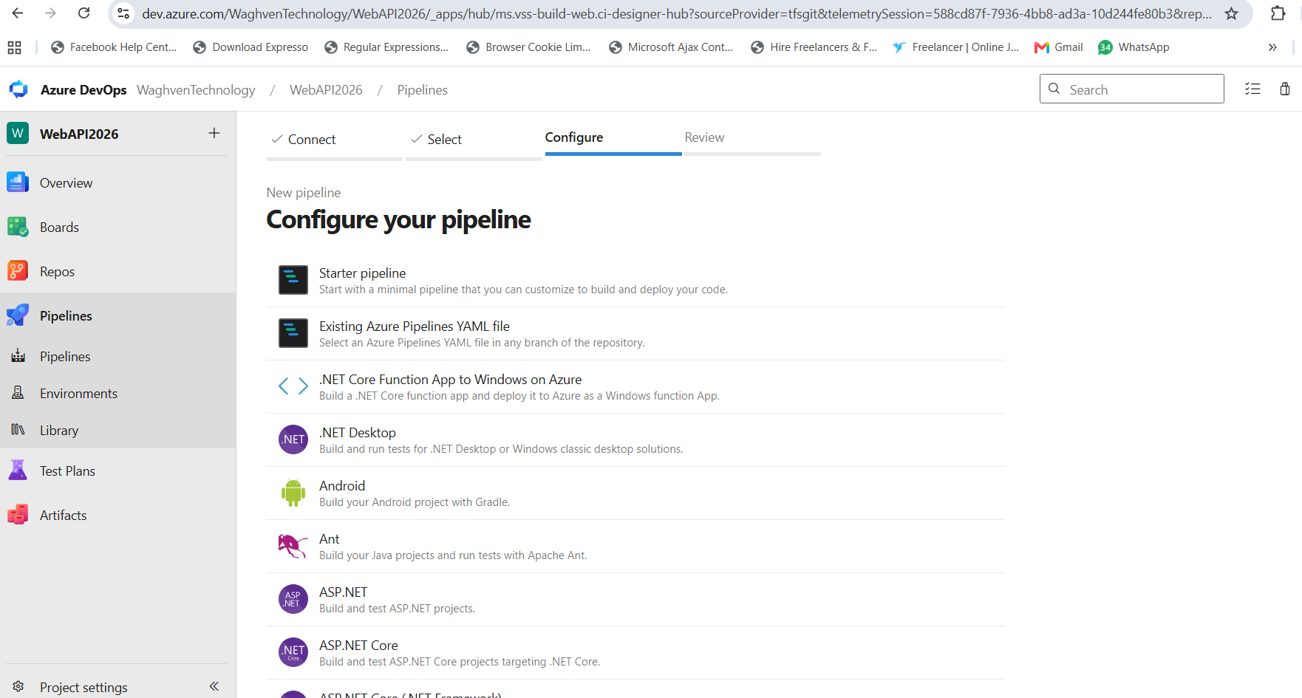
Select ASP.Net Core in above and create yml file according
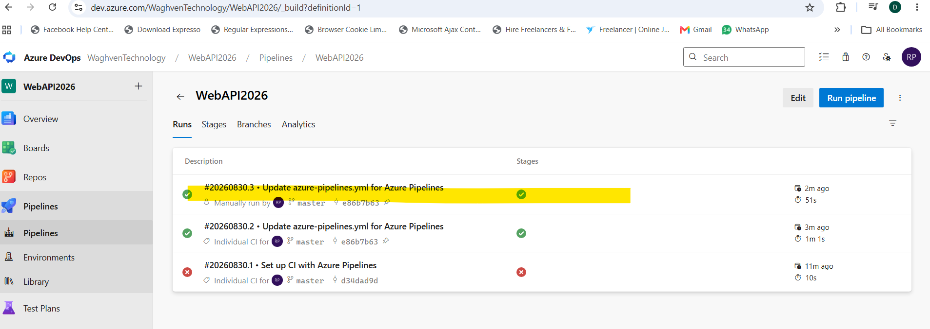
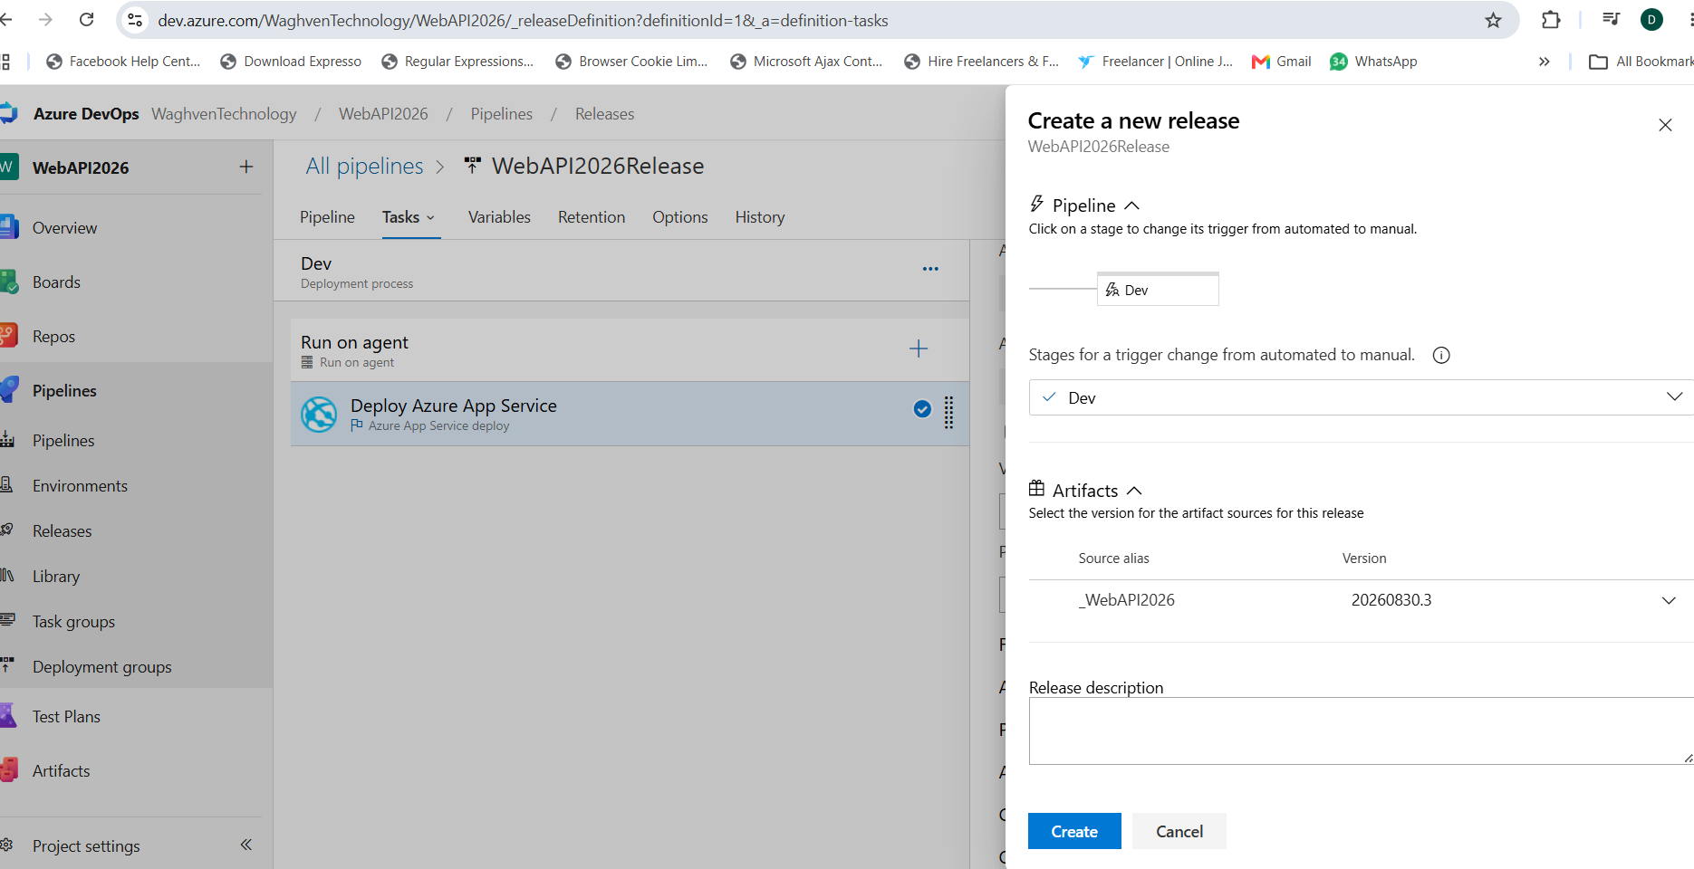
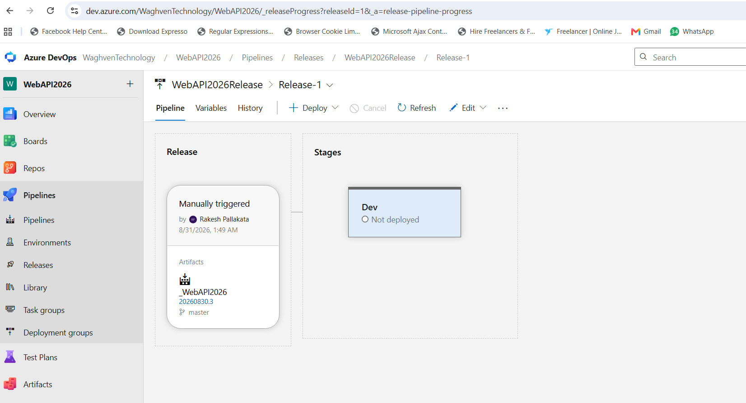
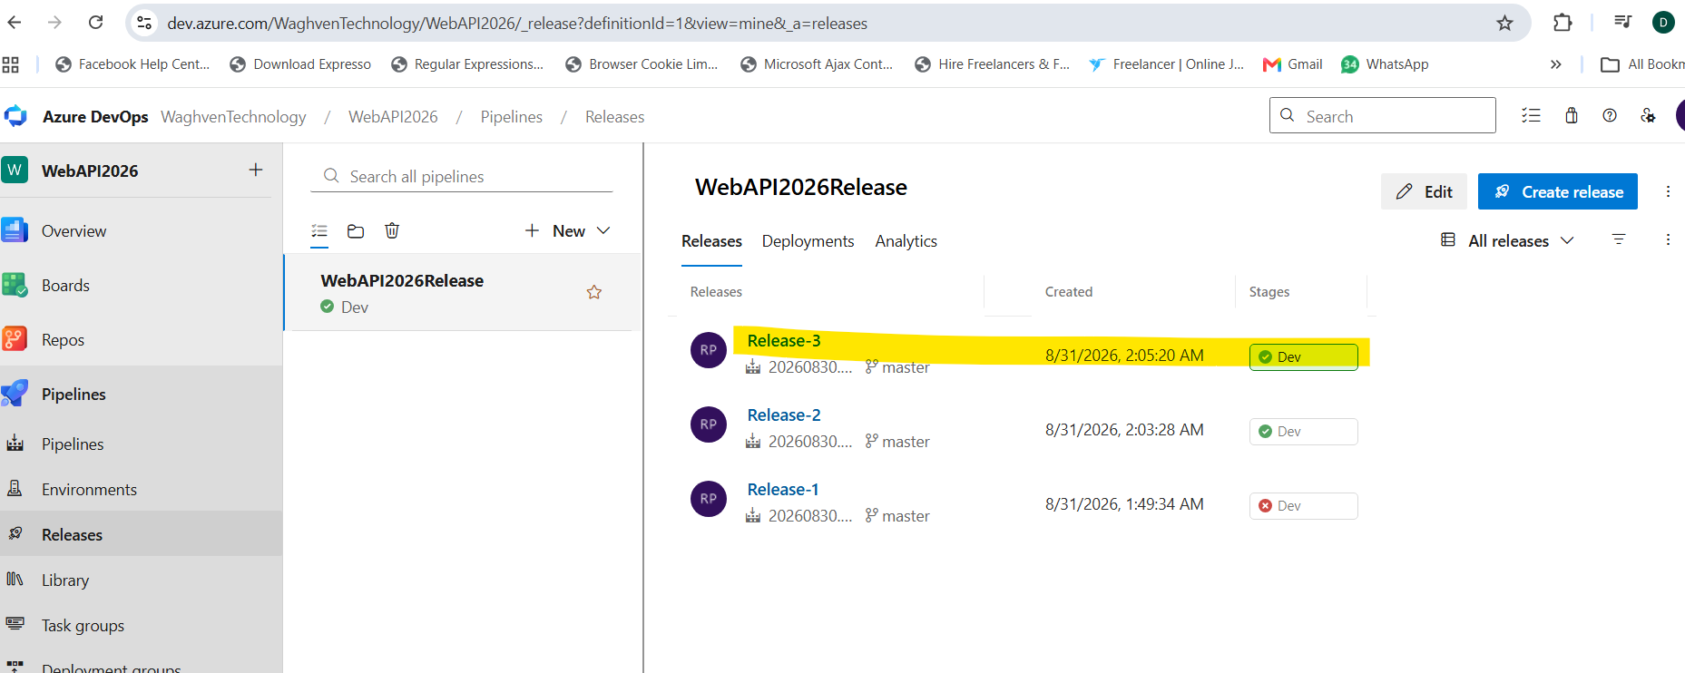
Changes deployed at below site
https://testwebapi2026-h8bcdpe2dcgfcmfm.southindia-01.azurewebsites.net/swagger/index.html
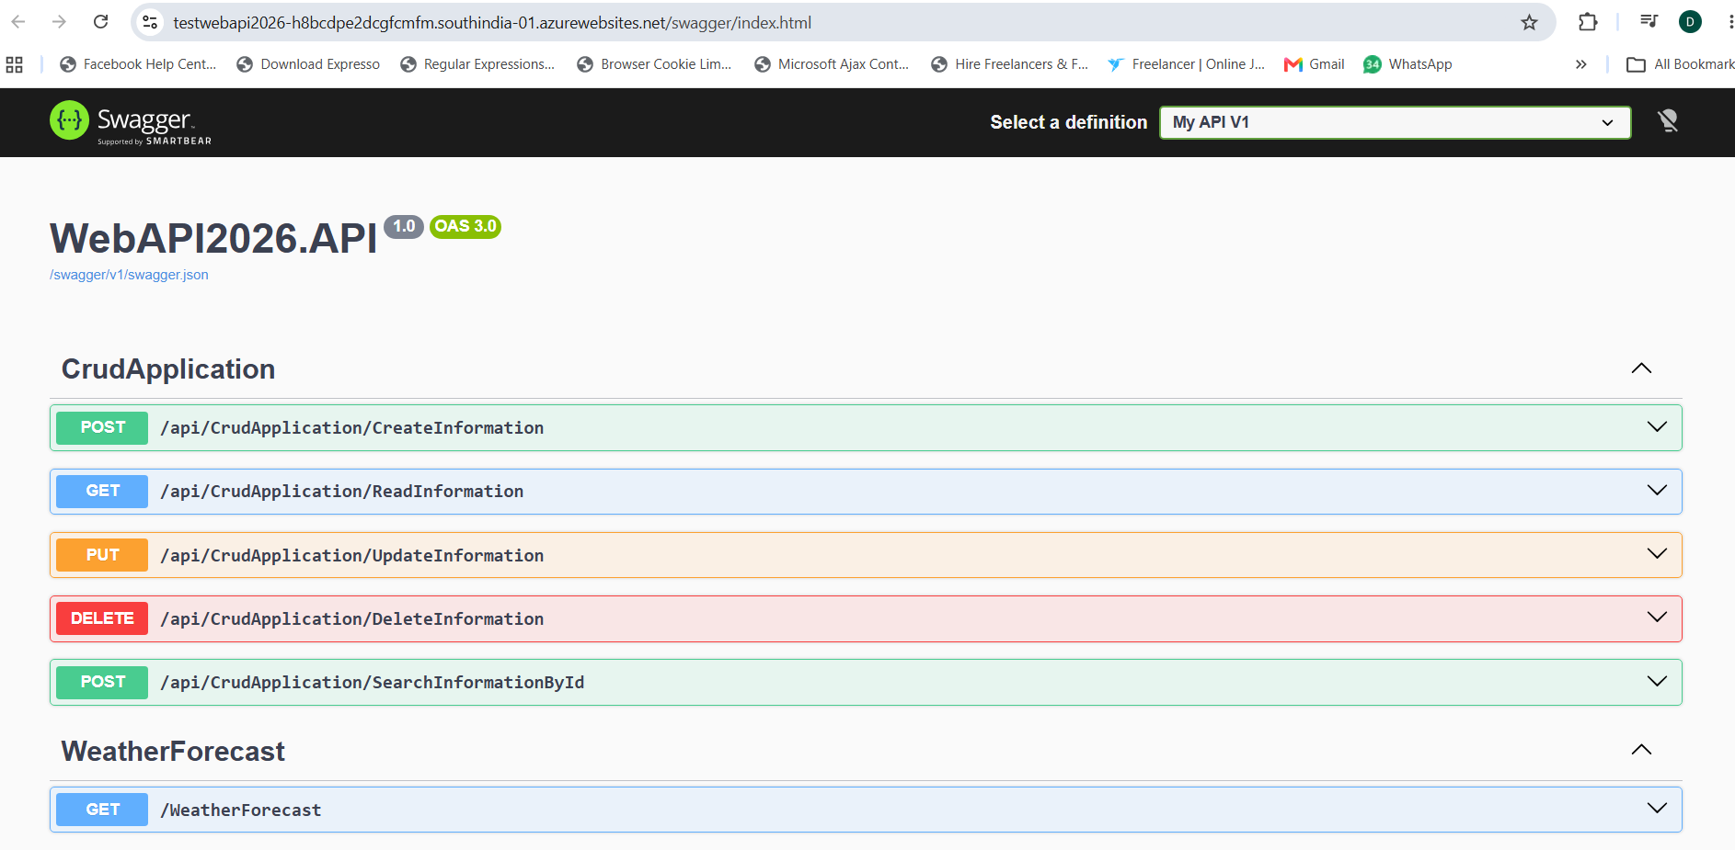
Currently we get below error to endpoints
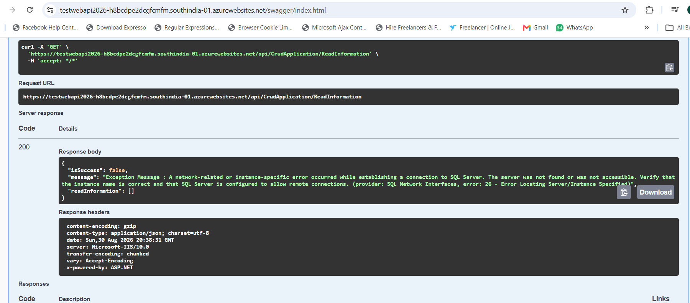
After raising PR build automatically triggered
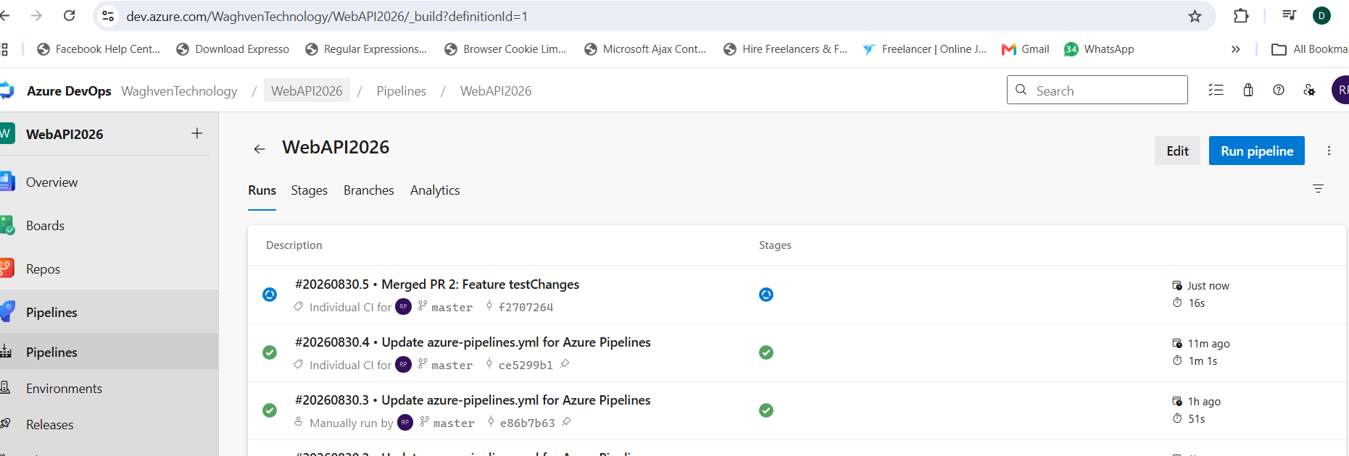
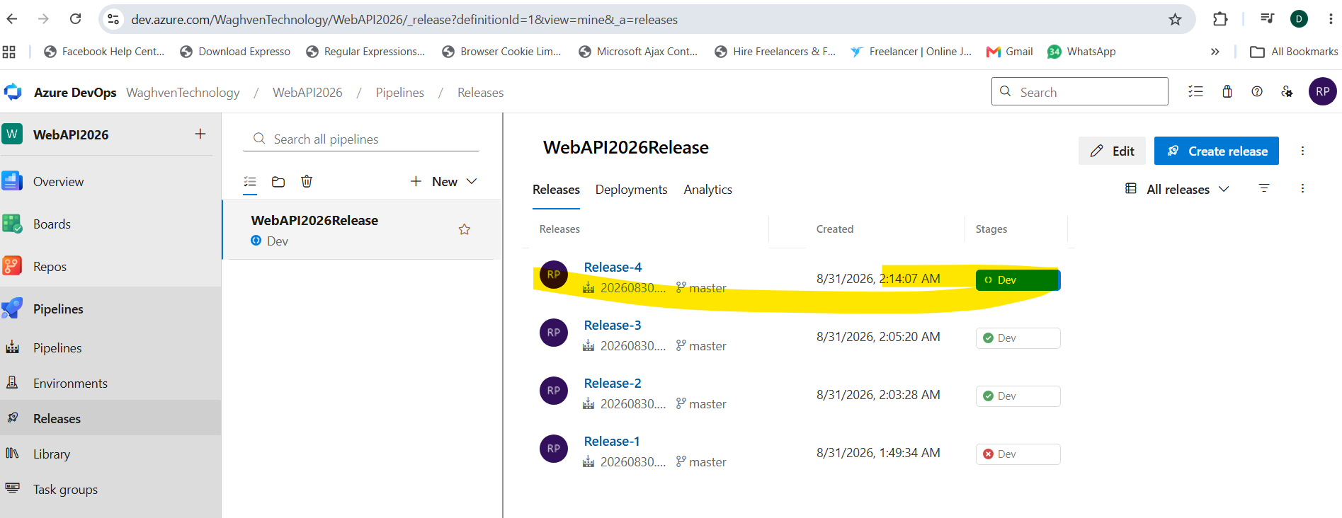

- Deploy .NET 10 Web API (CRUD) to Azure App Service & Azure SQL (Step-by-Step)
Create Azure SQL server which will support above web API from backend
https://youtu.be/x3lN-TTujmQ

server name – crudazuresqlerver
Azure servier Admin- AzureServerAdmin
Password – Pune@123
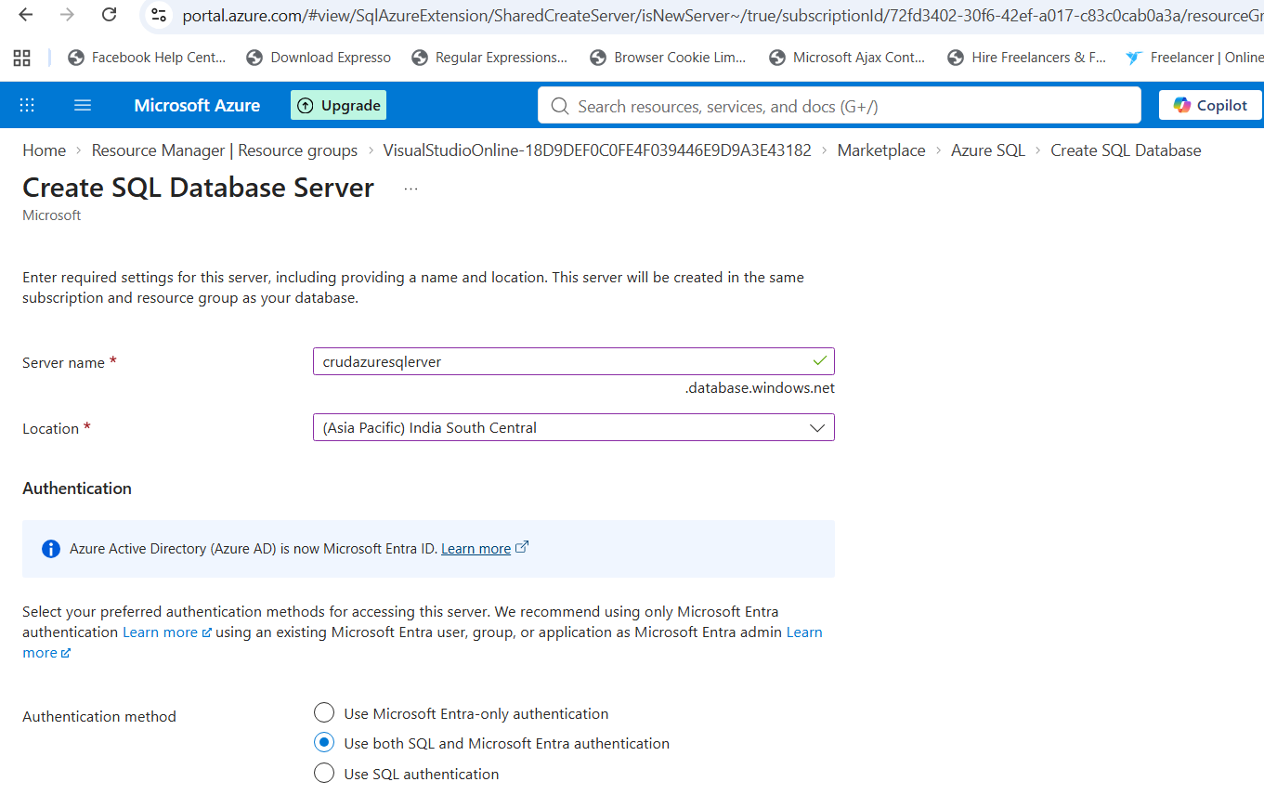

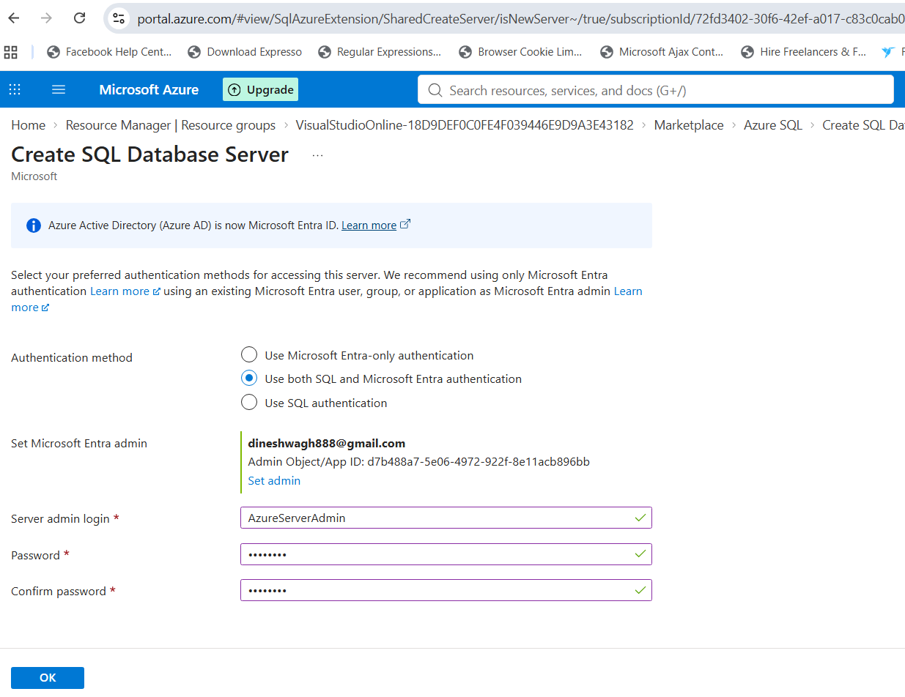

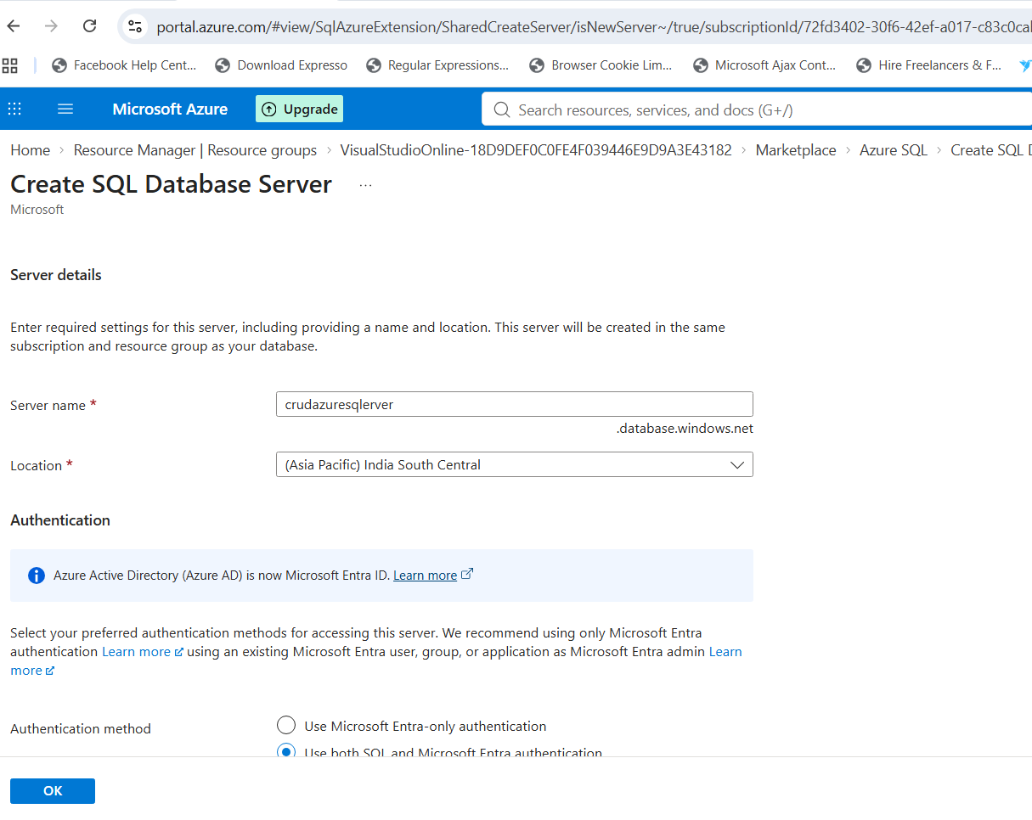
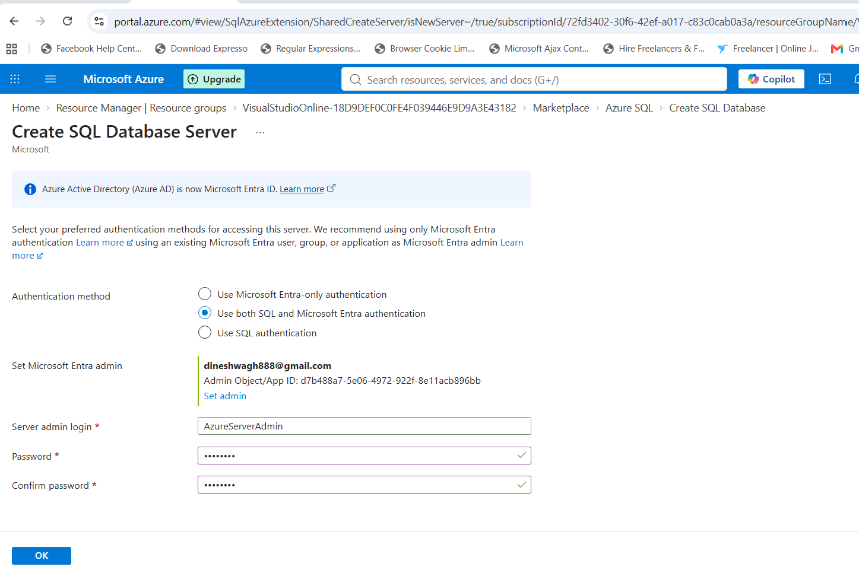
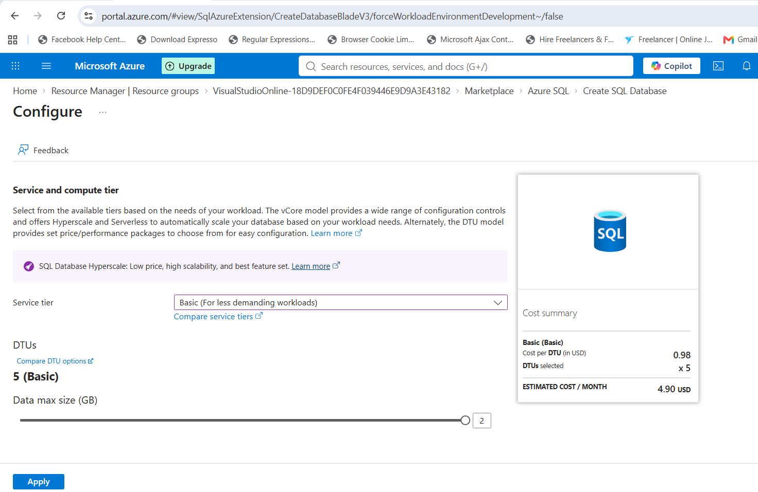

Now go to sql server editor with sql authentication
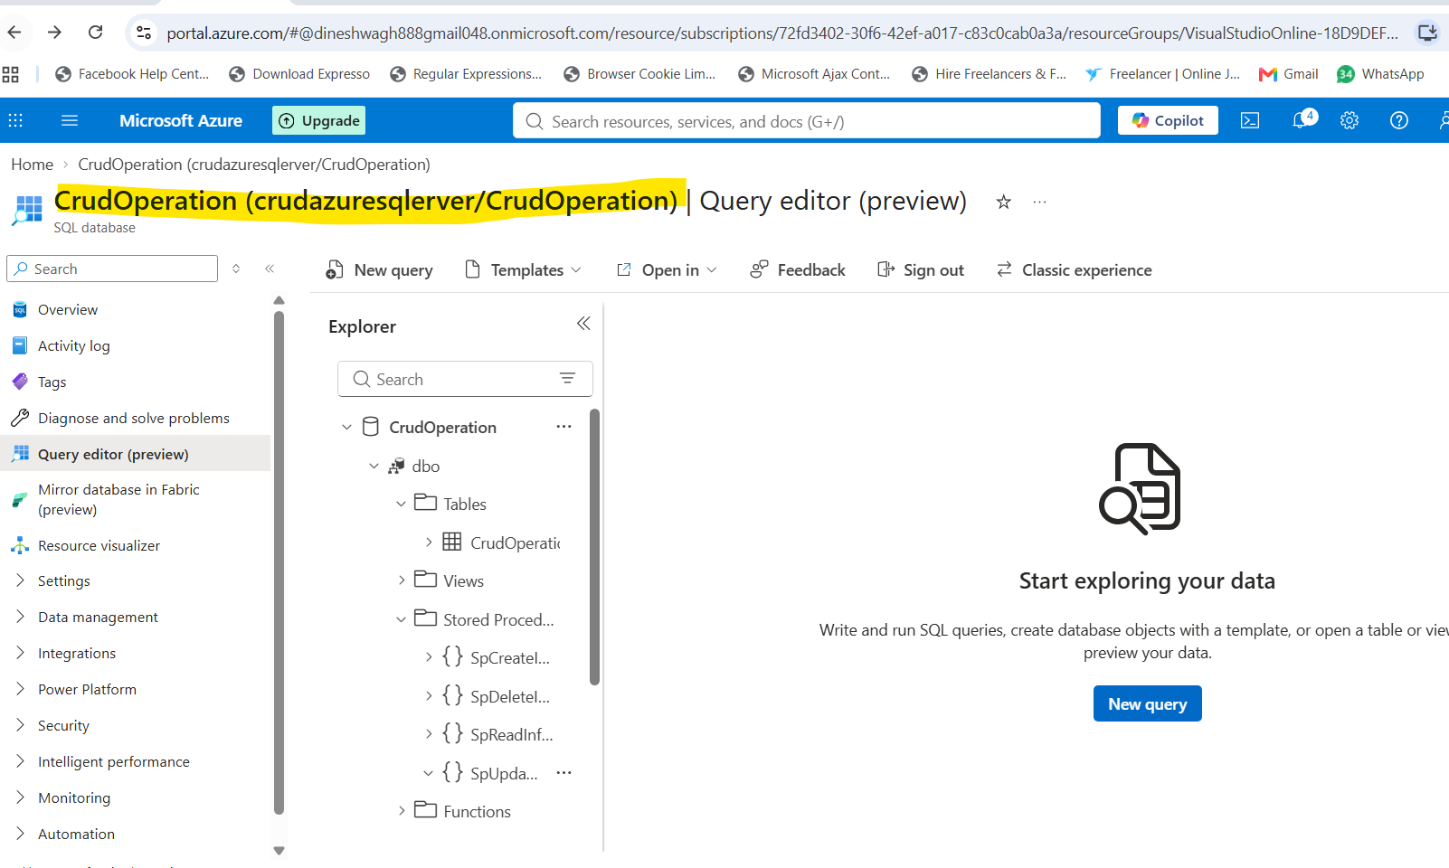
For authentication it may give error so add the network IP details. Once IP address is added you can access the Azure queery editor. Add the tables and stored procedures.
Once done run the web App service
https://testwebapi2026-h8bcdpe2dcgfcmfm.southindia-01.azurewebsites.net/swagger/index.html
and now it is working and giving data from Azure server
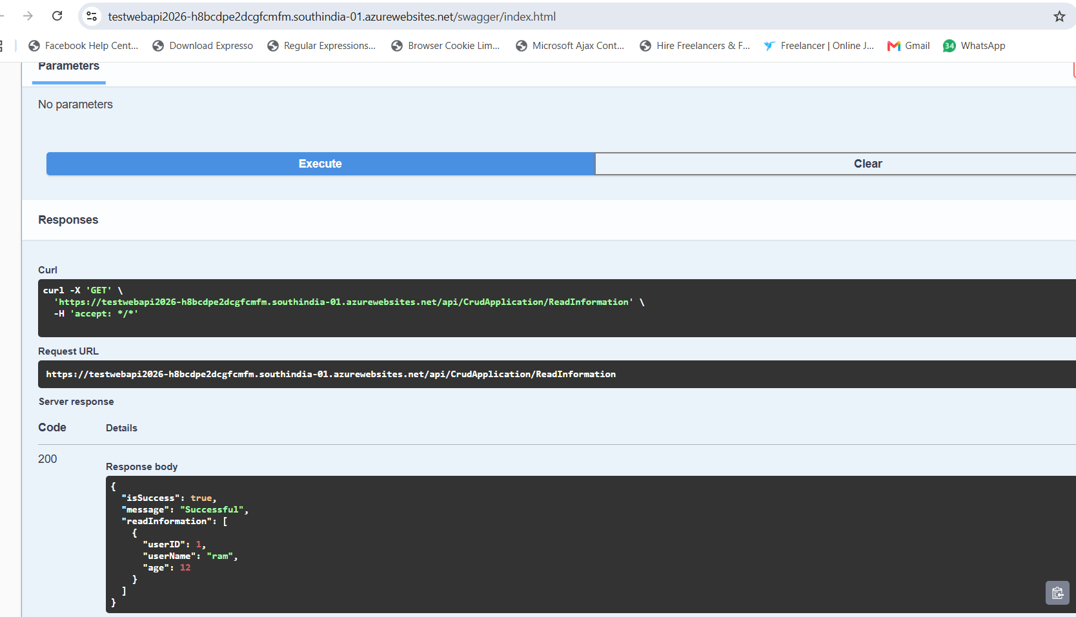
- Don't Just Code, Architect: Complete Full-Stack Build with .NET 10, Angular 21, Claude & Azure
https://youtu.be/zlybQJVLYrQ?list=PLVlM_EVY85XsKwORCZ5_zH_eXp8me-ilM
Database Script:
https://github.com/learnsmartcoding/smartcertify-api-clean-architecture-dotnet9/blob/main/LSC.SmartCertify.Infrastructure/Database_Scripts/SmartCertify.sql
.Net Core 9-
https://github.com/learnsmartcoding/smartcertify-api-clean-architecture-dotnet9
Angular 19:
https://github.com/learnsmartcoding/smartcertify-ui-angular19
Azure Function:
https://github.com/learnsmartcoding/smartcertify-functions-dotnet9
Demo App:
https://smartcertify-web.azurewebsites.net/home

at 1.22.33 how to work scalar- it works like Swagger
at 1.25.44
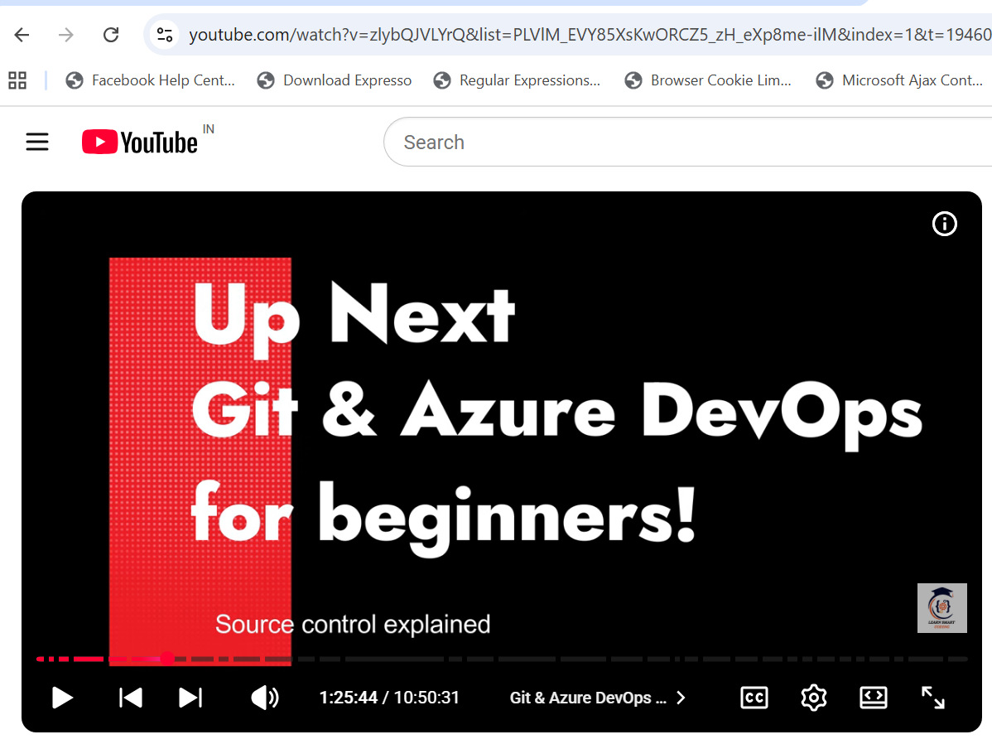

DevOps Repo from 1.25
smartcertify.api
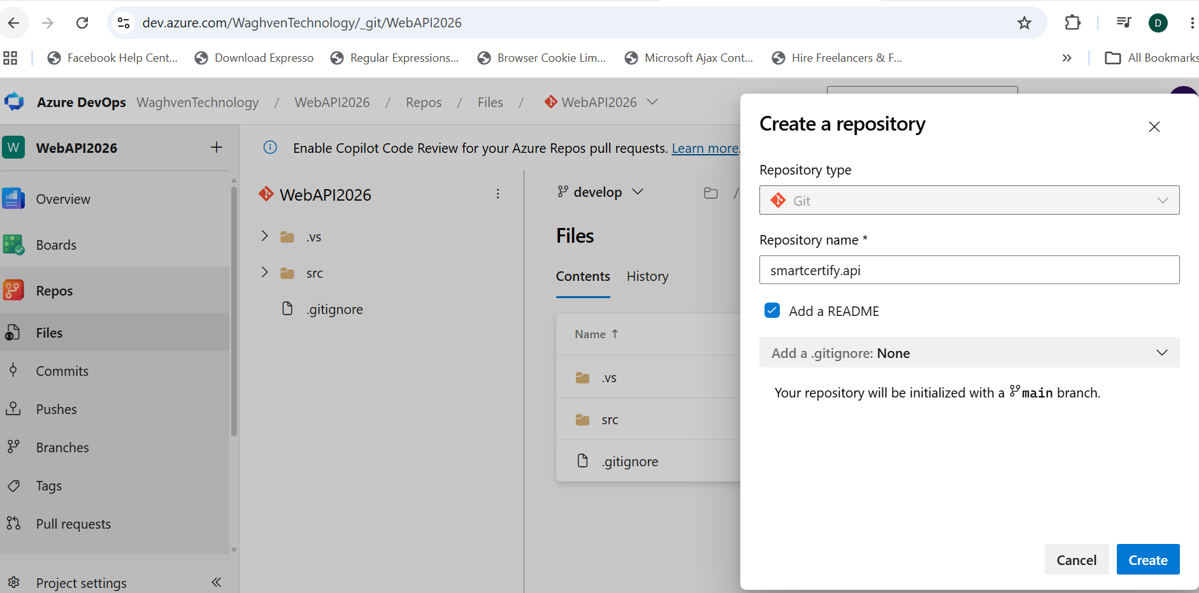
https://WaghvenTechnology@dev.azure.com/WaghvenTechnology/WebAPI2026/_git/smartcertify.api
check the command in below file to move project from local folder to Azure DevOps-
Commands to move Project to Azure.txt
Create SQL server DB-
server name – crudazuresqlerver
Azure servier Admin- AzureServerAdmin
Password – Pune@123
DB name- SmartCertify

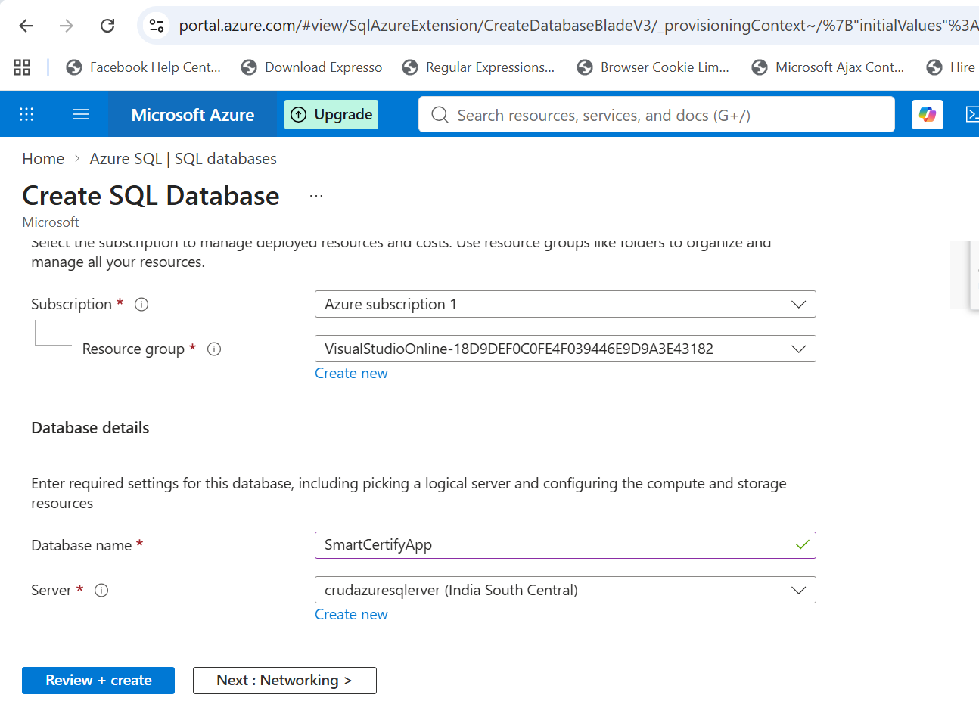
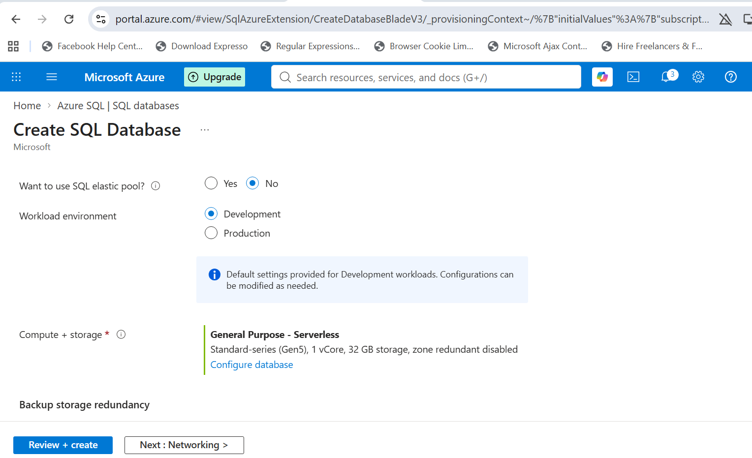

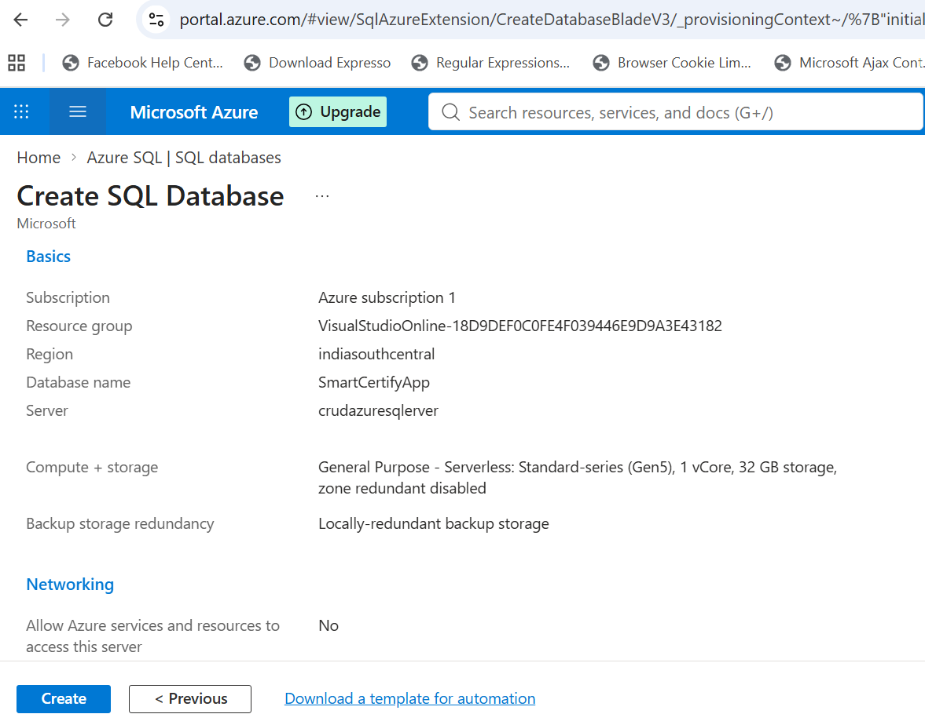

ConnectionString-
Server=tcp:crudazuresqlerver.database.windows.net,1433;Initial Catalog= SmartCertify;Persist Security Info=False;User ID=AzureServerAdmin;Password=Pune@123;MultipleActiveResultSets=False;Encrypt=True;TrustServerCertificate=False;Connection Timeout=30;
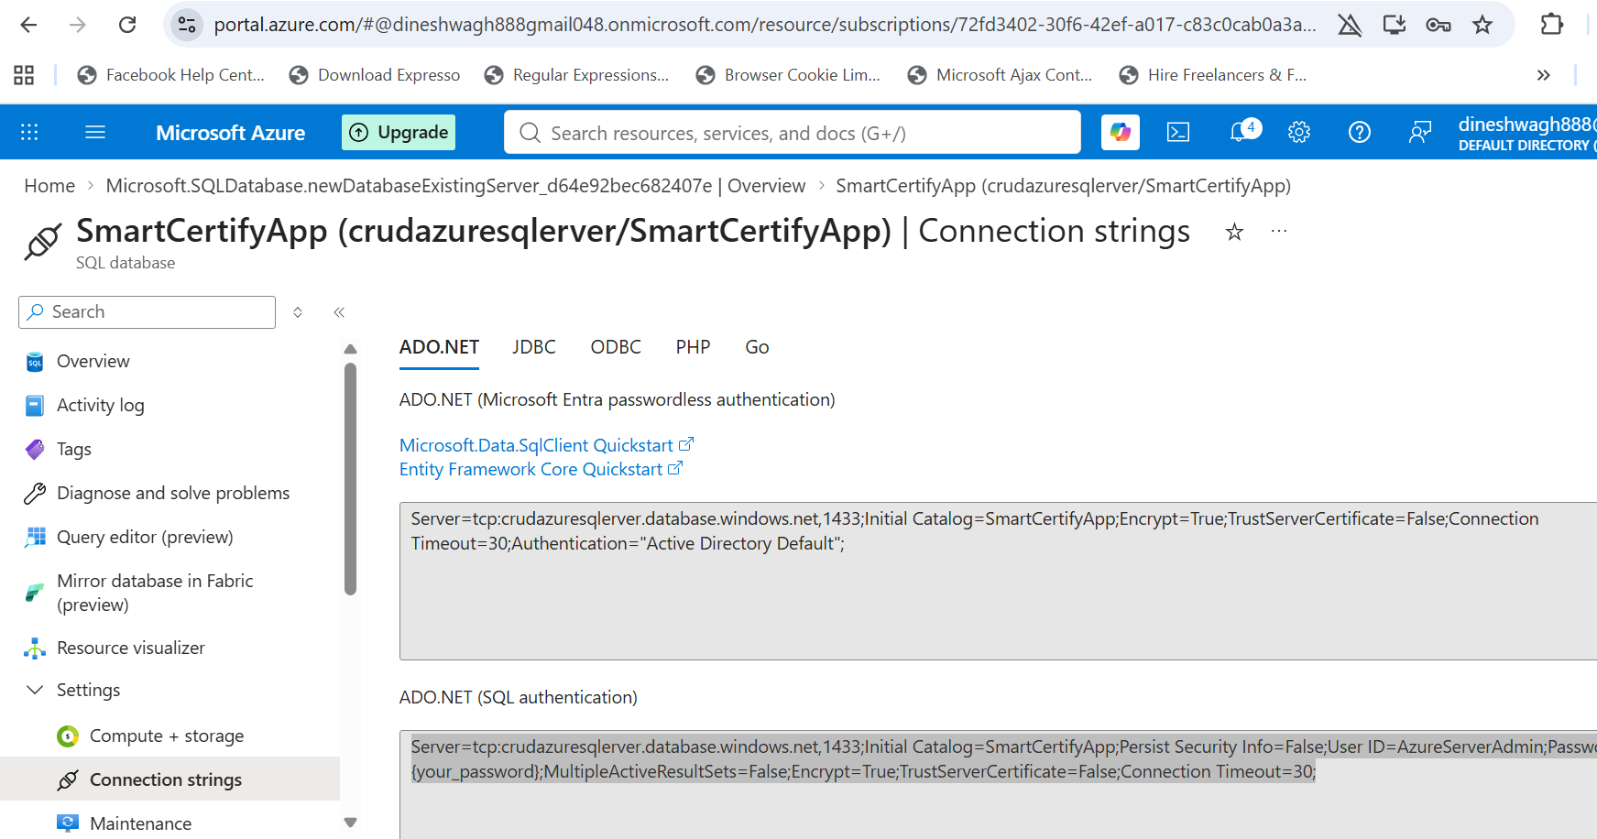

Login to Azure DB using local SQL server-
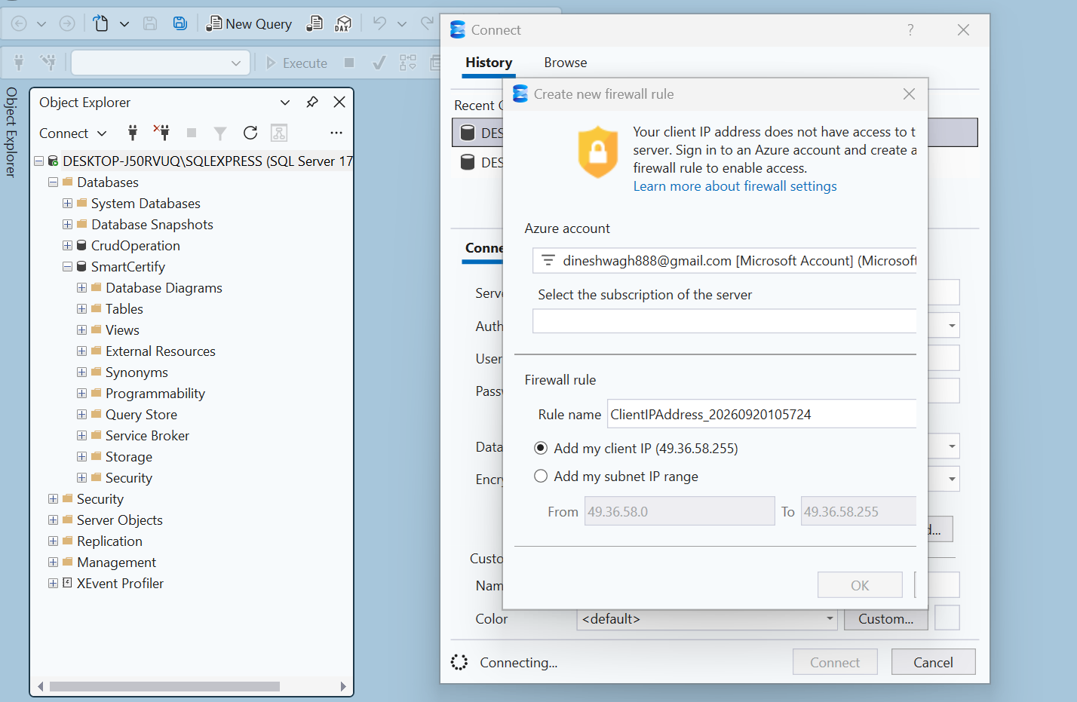

Add Firewall rule in Azure-
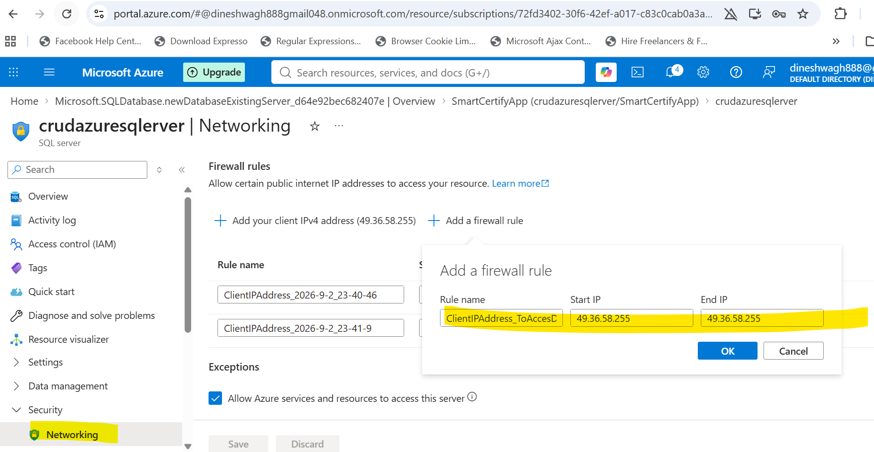

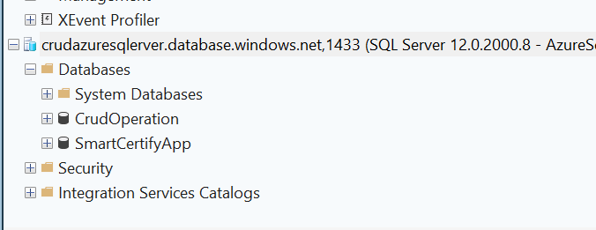

Angular Implementation start from 2.10
https://angular.dev/installation#prerequisites
done til 3.02
.Net Core Web API –
3.45
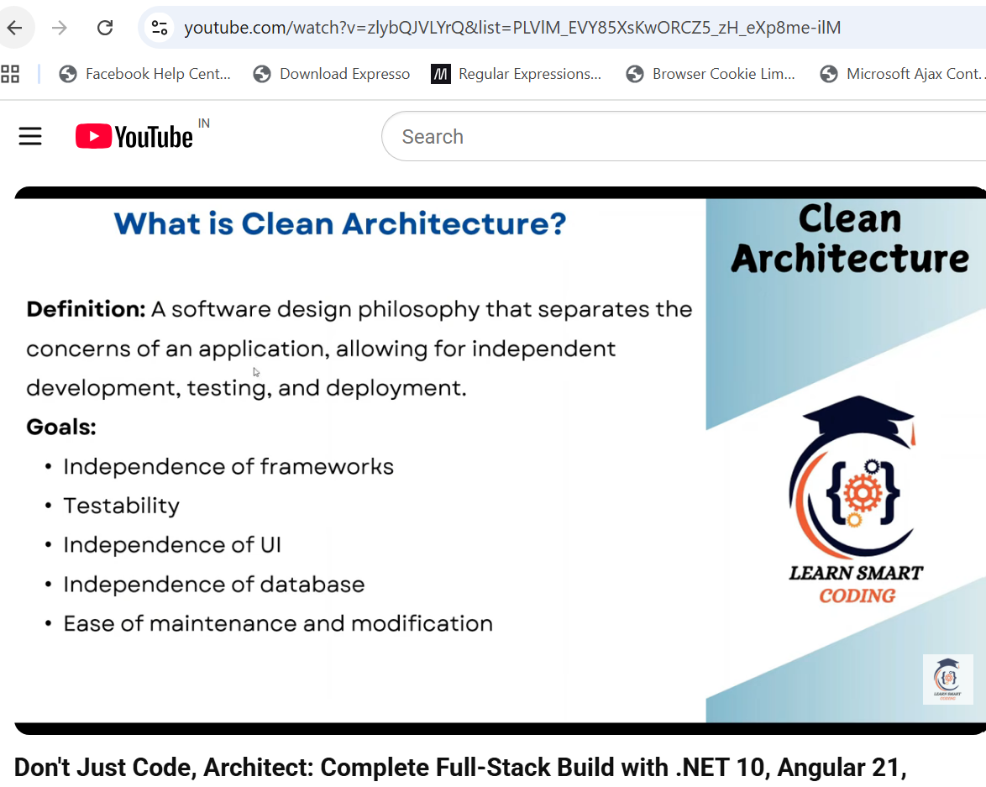
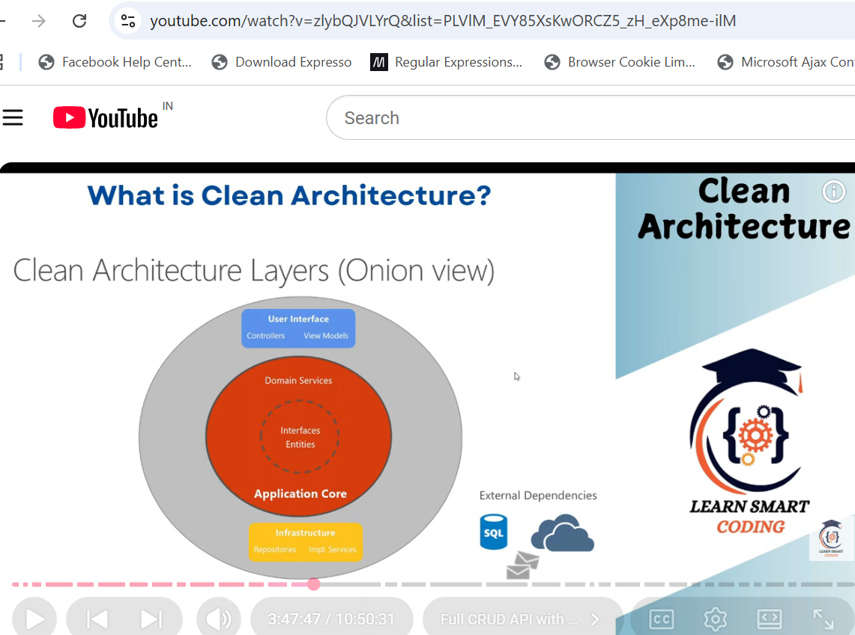
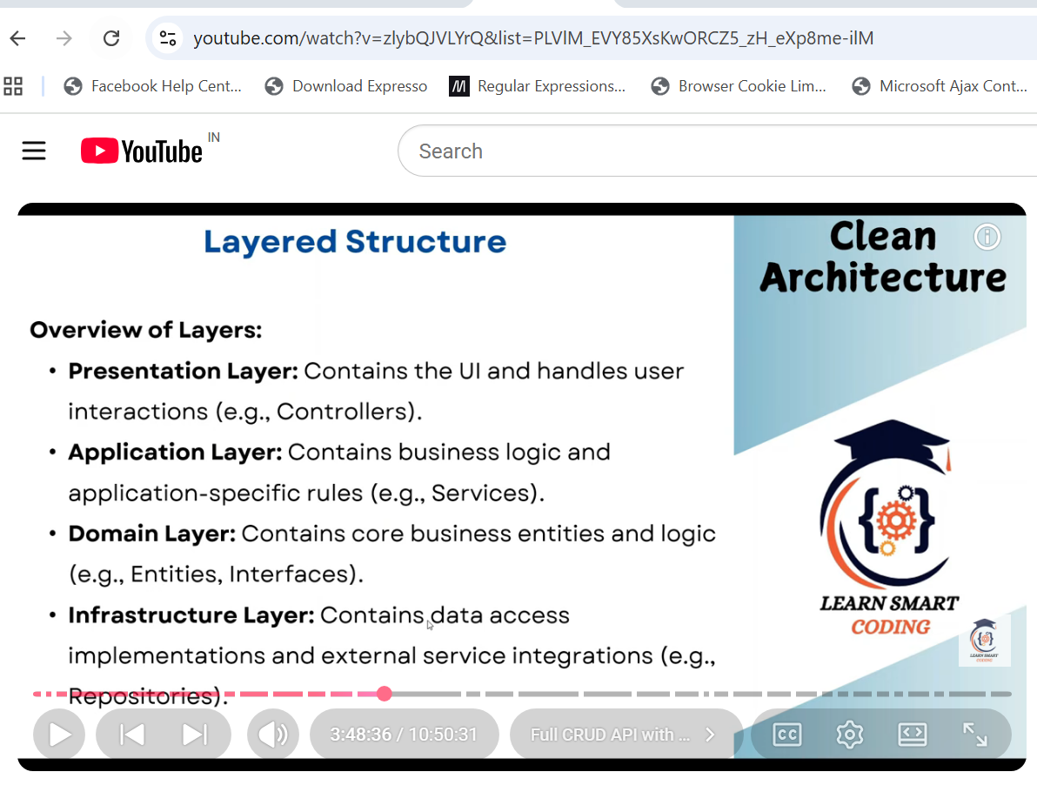
At 4.53, again Agular UI started
At 5.27, Azure SD B2C authentication-
  - To 6.12 Azure Active directory
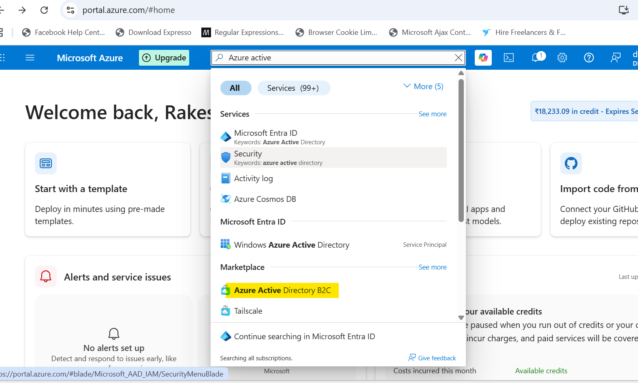
From 6.12 .net core web API deployment
From 8.00, Azure functions
At 8.30, Azure function localhost.json file
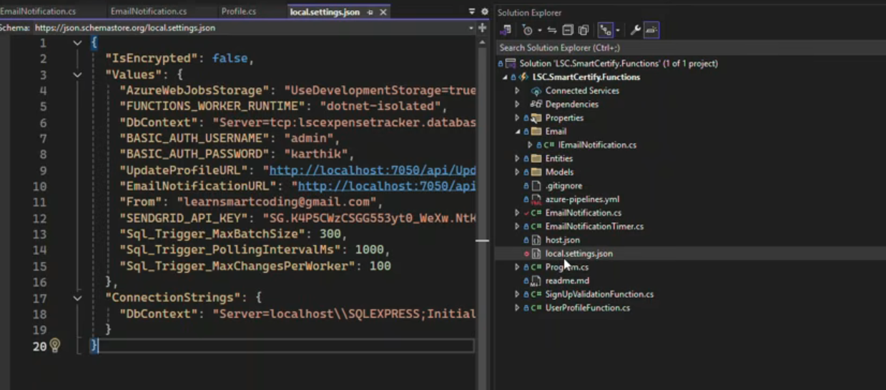
At 8.34, Azure AD B2C claims
At 8.52, background service implementation
At 9.02, Send Email notifications
At 9.23, Secure Image upload to Azure storage
At 9.57, Angular API , Role based authentication
At 10.05, Azure Key Vault
At 10.35, Azure Service principles and Managed entity
